**Ministry of Higher Education and Scientific Research**

**University of Sousse**

**Higher Institute of Management of Sousse**



**End of Study Project**

**In Order to obtain the**

**FUNDAMENTAL LICENSE IN MANAGEMENT COMPUTING**

Design and development of an e-commerce web application For Upper Limb Prosthesis



Academic supervisor:

Mrs. Jihene Tounsi

Professional supervisor:

Mr. Mohamed DHAOUEFI

Created By:

Hamdi Bouzayane

University Year 2019/2020

**Acknowledgments**

**General Introduction**

The project entitled " Upper Limb Prosthetic: R&D "is inspired from the two major paramedical prosthetics & orthopedics' fields. The project was held at CURE BIONICS aiming to offer the first commercialized, made in Tunisia, powered upper limb prosthesis, the goal of this project is to help CURE BIONICS develop their marketing strategies by creating a web application in order to present the company and its products, and also develop a friendly environment for potential customers and allow them to explore and order products online and create an innovative system to manage the application from customers’ orders, to managing the application’s content.

This report presents all the steps taken to develop the application. It contains six chapters organized as follows: The first chapter entitled "General Context- of The Project" is devoted to the presentation of the project and the host organization, as well as reviewing similar applications, and then selecting the development methodology adopted. The second chapter entitled “Work Environment and General Architecture” where we’ll present the physical and logical architectures, the tools used and the different elements of development environments. Then in the third chapter entitled "Sprint 0: Analysis and specification of needs" focuses on the identification of the actors, the description of functional and non-functional needs, the elaboration of the product backlog, finally we’ll share some of the designs and models we created before starting the implementation of the application. In Chapters 4, 5 and 6 describe respectively the realization of Sprints 1, 2, and 3 Each of these chapters will describe the different conceptual aspects, implementation details, and so on, than the realization of the tests. Finally, each sprint will end with a presentation of tools follow-up.

Finally, we will close this report with a general conclusion in which we summarize the different steps followed for the elaboration of this project as well as its eventual perspectives.

# Chapter 1: General Context- of The Project

**Plan :**

## Presentation of the hosting environment “CURE BIONICS”

## Project introduction

## Market study

## Critiques of the existing and the added value of this project

## Adopted Method

# Chapter 1: General Context- of The Project

### Introduction:

In this chapter, we’ll present the hosting environment and introduce the project that will be carried out. Then, we'll examine existing similar applications, identify the limits that arise and take it into consideration in order to offer an application that meets the needs of my hosting environment. Finally, we'll highlight the working method adopted to deliver this project.

## Presentation of the hosting environment “CURE BIONICS”

Cure Bionics is a Tunisian startup created in 2018 by Mr. DHAOUAFI Mohamed, an embedded systems and electronics engineer. Cure Bionics aims to empower people with limb differences by developing affordable and innovative solutions. Cure Bionics works on two axes which are: assistive and rehabilitation devices and that’s using several technologies such as

* 3D printing
* 3D scanning
* Artificial intelligence
* Virtual Reality and gamification
* Computer Assisted Design (CAD)

However, Cure Bionics focuses currently on 3D-printed a bionic arm which’s developed by a multidiscipline team of engineers and interns (electronics, mechanical design, marketing, product designers, etc.).

## 

FIGURE 1: Cure Bionics Startup’s Logo

## Project introduction:

The project is based on creating a web application to help our hosting environment follow its marketing strategy by introducing CureBionics to its customers, investors and clinicians, and also allowing customers to purchase and order prosthetics and 3D printed Covers.

The application provides CureBionics a self-made CMS (Content Management System) tool that allows them to manage their products, orders received, and their web application content.

## Market study

In this part we will present CureBionics’ current website, and we’ll present similar applications on an international scale.

#### Current Website:

Currently CureBionics use a free version website on “Wix” platform: <https://dhaouafimed.wixsite.com/curetunisie>

* Advantages:
* High-performance single-page web application that uses high-definition videos and pictures to showcase Cure Bionics to the public.
* “Wix” takes care of the hosted site security without compromising speed.
* Weakness:
* The free plan doesn’t remove ads from the Website.
* Drag and drop design that limits the creativity of the creator.
* Not responsive on all type of screens (mobile/laptop).
* Doesn’t allow customers to order products.
* Doesn’t allow customers to subscribe to a newsletter.

#### International Competitors’ Websites:

There is no local manufacturer of bionic prostheses, we only have distributors of international brands in Tunisia, so all our competitors are international.

Among these competitors, we are talking about:

* Open Bionics:



FIGURE 2: Open Bionics’ Logo

* Advantages:
* High-performance multi-page web application that presents Open Bionics activates and products with Videos and pictures.
* Allows customers to buy and order Open Bionics’ products.
* Allows customers to follow Open Bionics and all of their new products.
* Weakness:
* Created with WordPress (CMS) Drag and drop design that limits the creativity of the creator.
* Some pages aren’t responsive.

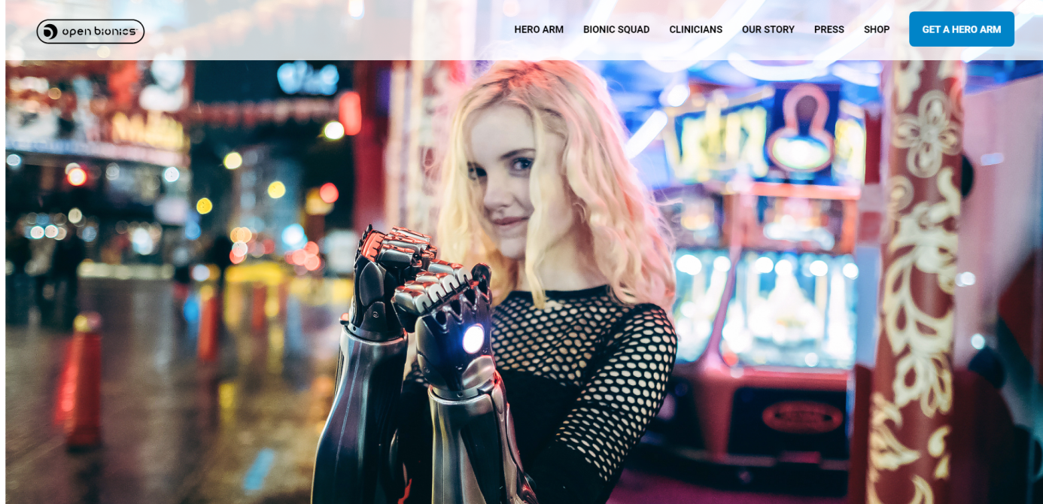

FIGURE 4: Open Bionics’ Home page

* Unlimited Tomorrow:



FIGURE 3: Unlimited Tomorrow’s Logo

* Advantages:
* High-performance multi-page web application that presents Open Bionics activates and products with Videos and pictures.
* Allows customers to order a “True Limb”.
* Allows customers know the work process of Unlimited Tomorrow.
* Good User Experience UI.
* Weakness:
* Created with WordPress (CMS) Drag and drop design that limits the creativity of the creator.
* Doesn’t have a newsletter to let the customers follow the Company and there new activates.

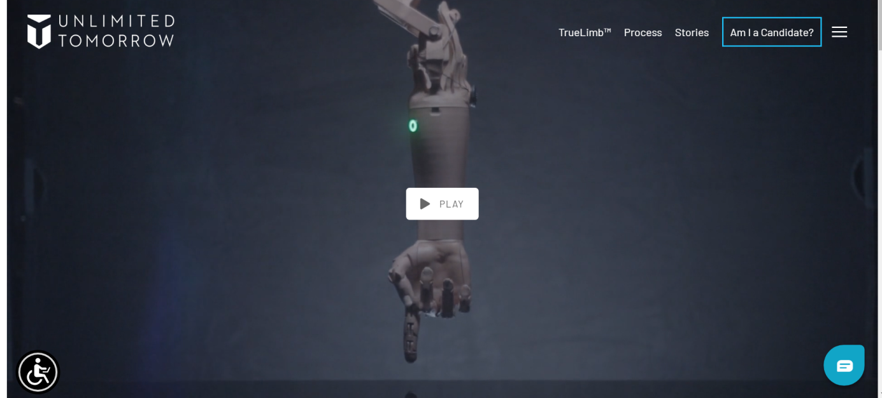

FIGURE 5: Unlimited Tomorrow’s Home Page

## Critique of the existing and the added value of this project

Although competitive websites have advantages, they also have many disadvantages unbearable. So we propose a solution in which we will correct Implement solutions and add new innovative features, such as:

### An innovative process to manage the content of the web applications, allowing administrator to create new employees and set their roles:

### Sales manager, who is allowed to process customer orders and is responsible for adding, deleting or updating products in the E-commerce store of the web application very easily from a well-designed User Interface while providing a good User experience.

### Content managers, can change the content on the homepage and news page, and can also process newsletters and send them to subscribers.

### Creating web pages to get the customers more connected to Cure Bionics by allowing the Content manager to post blogs and news about the company while keeping the web application functional and also grant a good UI/UX to all visitors.

## Adopted Method

In the IT field, it is very useful to choose a project management method to ensure an organized development process and consequently give birth to a reliable product with a focus on customer satisfaction.

In this part, we’ll first choose a working method, then we’ll present it and finally, we’ll cite the different roles of this method.

* 1. **Choice of the development method:**

We decided to compare the classic method with the agile method, and according to this comparison, we will choose the most efficient method for this project.

Table 1: presents a comparison between the agile method and the classic method. [1]

|  |  |  |
| --- | --- | --- |
|  | classic method | agile method |
| Life Cycle | This is a process that only follows a top-down approach. It is based on sequential phasing without feedback, organized around these phases:  1- Requirements specification  2- Design  3- Implementation  4- Test  5- Installation  6- Maintenance | This is an iterative and incremental phasing. The project is organized around short sprints of two to four weeks which will deliver an actionable part of the solution. |
| Quality Control | In traditional management, quality control is carried out at the end of the development cycle, once the product is finished. | In an agile method, quality control is performed regularly for each sprint. |
| Reaction to Changes | This method offers very little or no scope for changes from the original plan. Resistance to any proposed changes is on the pretext of not disrupting the project schedule. | The client is associated with the control very frequently. Also allows the client to visualize and verifies the results of each sprint.  The agile method is very flexible because It offers a lot of possibilities for changes and allows the exchange of new ideas that will help improve the product further. |
| Goals | Monitor the process step by step and fulfill the Initial promises. | Satisfy the customers with delivered solution. |

TABLE 1: comparison between the agile method and the classic method

After the previous comparison, we decided to use iterative methods and incremental methods (such as agile methods) to avoid the phase difference between basic requirements and current requirements, because requirements will change or become more precise over time.

Agile methods accept the fact that requirements cannot be fixed, so they can ensure communication with customers, and by expressing opinions on the quality of delivered products, explaining their requirements and pointing out whether there are requirements, so that customers can participate in changes in the development requirements of the project. In addition, this method guarantees the good quality of the product due to continuous testing, which can minimize errors.

* This project will use the “SCRUM” method which is the most popular of the “Agile” methods.
  1. **Presentation of SCRUM: [1]**

Scrum is an agile method used for managing project development. These are the iterations to be done to get a complete and reliable project at the end of the day. These iterations are called sprints and are characterized by their short duration (standardizing to four weeks). At the start of each sprint, the SCRUM team selects a number of User Stories from the Product Backlog (according to their priorities) to build the Sprint Backlog which defines the goals for that sprint. At the end of each sprint, the development team must render an increment of the completed, tested, and deliverable product that will be incorporated into the next sprint.

To obtain the final product, the process described above should be repeated as many times as necessary.

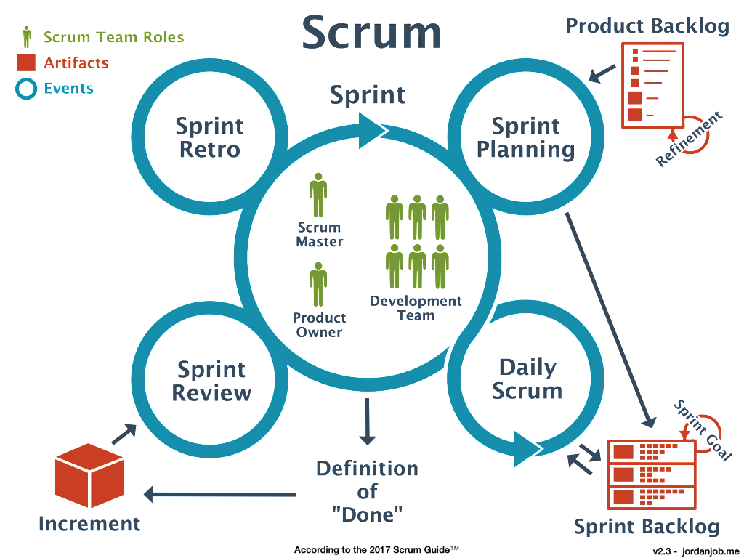

FIGURE 6: illustrates the life cycle of the SCRUM method

* 1. **SCRUM roles:**

The SCRUM method defines three roles: [3]

The Product Owner: is responsible for maximizing the value of the product and the work of the Development team. He is the one who carries the vision of the product to be achieved.

The SCRUM Master: is responsible for promoting and supporting Scrum. It fulfills its duties by helping everyone understand the theory, practice, rules and values ​​of Scrum. He is the leader of the Scrum team service. He helps everyone tailor their interactions with the Scrum team to maximize the value created by that team.

The SCRUM team (development team): is responsible for translating the requirements expressed by the product owner into usable functions. It is composed of professionals who provide incremental completed and possibly delivered products for each Sprint. Only members of the development team can create increments.

Conclusion:

In this chapter, we introduced the host organization and project environment. Subsequently, we studied the content that exists on the market and reviewed the existing content by describing the added value of the application. Then, we compared different development methods in order to select the appropriate method for the project, which will be introduced in the next chapter of this report.

The next chapter entitled sprint 0 represents the exploration phase, Its objective is to provide a clear vision of the project.

# Chapter 2: Work Environment and General Architecture

**Plan :**

## Introduction

## Work environment

## General architecture of the application

## Conclusion

## Introduction

In this chapter we’ll present our work environment, we’ll specify our material environment, our development environment and our software Development environment then we’ll highlight our General architecture of the application

## Work environment

#### Material environment

The realization of this project required as hardware environment a laptop computer whose characteristics are described in table 3:

|  |  |
| --- | --- |
| Computer | Dell |
| Owner | Hamdi Bouzayane |
| CPU | Intel core i5 7th Generation |
| Hardware | 1 To |
| RAM | 8 Go |
| Operating System | Windows 10 |

#### Development Environment

The different development tools used to build our application are described below:

|  |  |
| --- | --- |
|  | **ReactJS** is an [open-source](https://en.wikipedia.org/wiki/Open-source) [JavaScript library](https://en.wikipedia.org/wiki/JavaScript_library) for building [user interfaces](https://en.wikipedia.org/wiki/User_interfaces) or UI [1] component. It is maintained by [Facebook](https://en.wikipedia.org/wiki/Facebook) and a community of individual developers and companies. |
|  | **NodeJS** is an [open-source](https://en.wikipedia.org/wiki/Open-source_software) [JavaScript](https://en.wikipedia.org/wiki/JavaScript) runtime environment (Framework) that executes JavaScript code outside a [web browser](https://en.wikipedia.org/wiki/Web_browser). Node.js lets developers use JavaScript to write command line tools and for [server-side scripting](https://en.wikipedia.org/wiki/Server-side_scripting). |
|  | **ExpressJS** is a minimal and flexible Node.js web application framework that provides a robust set of features for web and mobile applications. It facilitates API development. |
|  | **MySQL** is an [open-source](https://en.wikipedia.org/wiki/Open-source_software) [relational database management system](https://en.wikipedia.org/wiki/Relational_database_management_system) that organizes data into one or more data tables in which data types may be related to each other and these relations help structure the data. |
|  | **Visual Studio Code** is a free [source-code editor](https://en.wikipedia.org/wiki/Source-code_editor) made by [Microsoft](https://en.wikipedia.org/wiki/Microsoft) supports [debugging](https://en.wikipedia.org/wiki/Debugging), [syntax highlighting](https://en.wikipedia.org/wiki/Syntax_highlighting), [intelligent code completion](https://en.wikipedia.org/wiki/Intelligent_code_completion), [snippets](https://en.wikipedia.org/wiki/Snippet_(programming)), [code refactoring](https://en.wikipedia.org/wiki/Code_refactoring), and embedded [Git](https://en.wikipedia.org/wiki/Git). |

|  |  |
| --- | --- |
|  | **ReactBootstrap** is a [free and open-source](https://en.wikipedia.org/wiki/Free_and_open-source) [CSS framework](https://en.wikipedia.org/wiki/CSS_framework) directed at responsive, [mobile-first](https://en.wikipedia.org/wiki/Responsive_web_design#Mobile_first,_unobtrusive_JavaScript,_and_progressive_enhancement) [front-end web development](https://en.wikipedia.org/wiki/Front-end_web_development), It contains [CSS](https://en.wikipedia.org/wiki/CSS) and [JavaScript](https://en.wikipedia.org/wiki/JavaScript)-based design templates. |
|  | **CSS 3** is designed to enable the separation of presentation and content, including [layout](https://en.wikipedia.org/wiki/Page_layout), [colors](https://en.wikipedia.org/wiki/Color), and [fonts](https://en.wikipedia.org/wiki/Typeface). This separation can improve content [accessibility](https://en.wikipedia.org/wiki/Accessibility), provide more flexibility and control in the specification of presentation characteristics. |
|  | **Sequelize** is a promise-based Node.js [ORM](https://en.wikipedia.org/wiki/Object-relational_mapping) for [MySQL](https://en.wikipedia.org/wiki/MySQL) It features solid transaction support, relations, eager and lazy loading, read replication and more. Sequelize follows [Semantic Versioning](http://semver.org/) and supports Node v10 and above. |

#### Software Development

In addition to that, other software tools are used during the project, such as:

|  |  |
| --- | --- |
|  | **Trello** is an online collaboration tool that allows for organize the tasks of a project into tables, each of which can be filled in with lists of notes that describe these team tasks, with attachments. It includes tools for commenting and collaborating with teammates. It is one of the best known tools in collaborative management such as Slack |
|  | **StarUML** It is an open source software used to model UML (Unified Modeling Language) diagrams. |
|  | **Postman** is a collaboration platform for API development. Postman's features simplify each step of building an API and streamline collaboration so you can create better APIs—faster. |

|  |  |
| --- | --- |
|  | **Photoshop** is graphic design software is at the core of just about every creative project, from photo editing and compositing to digital painting, animation, and graphic design. |
|  | **GitHub** is a web hosting service for projects. It allows user to store application codes in repositories and allow user manage these Git repositories, and manage versions of your source codes. In addition, it represents a platform for collaboration developers. |
|  | **Git** is a [distributed version-control](https://en.wikipedia.org/wiki/Distributed_version_control) system for tracking changes in [source code](https://en.wikipedia.org/wiki/Source_code) during [software development](https://en.wikipedia.org/wiki/Software_development), It is designed for coordinating work among [programmers](https://en.wikipedia.org/wiki/Programmer), but it can be used to track changes in any set of [files](https://en.wikipedia.org/wiki/Computer_file). Its goals include speed, [data integrity](https://en.wikipedia.org/wiki/Data_integrity), and support for distributed, non-linear workflows |

#### Protocol Data Unit

In this part we will specify the data exchange protocol between the client and the server. Then, we will present the data format used in this project.

##### Protocol Used

In this application the **HTTP** protocol was used to carry out the data communication between the client and the web server, we used these methods **POST**, **GET** and **DELETE** to manage the data sent from the web client to the server

##### Data Format Used

In this project we used the **JSON** (JavaScript Object Notation) data format it is a way to save data in an organized and easy-to-process way. This format is similar to the JavaScript object syntax because it is based on a subset of the JavaScript programming language.

## General architecture of the application

In this part, we will present the chosen software architecture, then, we will explain how it works by making an analogy with the MVC model.

#### Choice of software architecture

During the development of web applications, we create solutions that meet client needs using different architecture models. The most widely used of these is the **MVC** (Modal-View-Controller) model. However, there are more advanced patterns such as **Redux** and **Flux** that help to manage complex applications.

For this project, we chose to cooperate with **Redux** for a variety of reasons, first of all, the **React** **Redux** library is the official library of the React library, which provides links between user interfaces. In addition to that, **Redux** has also achieved many performance optimizations. Finally **Redux** helps write applications that are consistent in performance, run in different environments (client, server, and native) and are easy to test.

#### Functioning of the REDUX software architecture and analogy with the MVC architecture:

In this part, we will discuss the functionality of REDUX by explaining it and comparing to the MVC model

##### The MVC model architecture

Figure 10: MVC model architecture.

As we can see in the figure MVC data can flow in a bidirectional manner between the Model which’s the M in MVC, the Controller which’s the C in MVC and the View which’s the V in MVC, in the MVC architecture the data can flow two ways for example, if client press a button in the view (interface), it sends a message to the controller and that updates the model. The model changes some value, returns the value to the controller, and the controller refreshes the view.

##### REDUX model architecture

Figure 11: REDUX architecture.

As shown in the figure,  **REDUX** data can flow only in one direction for example if client presses a button in the **UI** (User Interface) it triggers an **Action** and that action sends data to the **Reducer**, then the **Reducer** updates the S**tates** in the **Store** part of **REDUX** and by updating the states the **View** updates dynamically .

##### The analogy between REDUX and MVC

The MVC architecture, we are used to models, views and controllers. However in Redux we are dealing with actions, reducers, stores and components. Trying to “translate” MVC to Redux is tricky but here is how we can do it:

**Actions = Controller.** Think of the actions as the controller. Whenever the user wants something to happen in the application, the app has to dispatch an action. Just like in MVC where the app would have to call a controller endpoint.

**Reducer = Model.** The reducers will be in charge of holding the current state of the application. It will also be the part that decides what to do when an action is called. While in MVC we might have a model with a method, but with Redux you would have a reducer handle an action to update the state in the store.

**Stores** The store is Redux specific and doesn’t have an equivalent in MVC. The store is like a container for the state that aggregates all of the reducers. It has a method to the get the current state, and exposes ways to subscribe to the state changes.

**Components = Views.**Components are smart views. They display the information that they get from the state

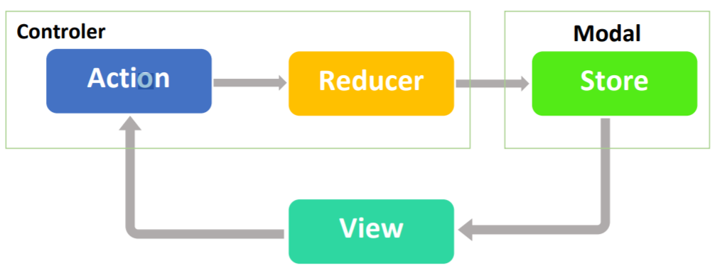

Figure 12: analogy between MVC model and REDUX

## Conclusion:

In this chapter we’ll talked about our work environment, then we’ll highlight our General architecture of the application and we took a close look on the MVC and REDUX models architectures and we saw the analogy between them

In next chapter we’ll start our project process with sprint 0

# Chapter 3: Sprint 0

**Plan :**

## Capturing Needs

## Project management with Scrum

## Models and Design

## Deployment Diagram

# Chapter 3: Sprint 0

Introduction

In this chapter, we will focus on sprint 0, which is the first step in the project process. At first glance, we will identify the actors, propose functional and non-functional requirements, and explain the method used. Next, we will outline some models of the application program interface, introduce the different environments in which the application works, prepare the development environment in parallel, and explain the concept of the architecture used in this project. Finally, we will show the logical static view and physical infrastructure of the system through the global class diagram and the deployment diagram.

## Capturing Needs

In this part, we will first identify the different actors of the application, then, we will cite the functional and non-functional requirements required by the project.

#### Define actors:

Actors are the roles played by stakeholders outside the system to be modeled, and they will interact directly with this system, it can be a human user or another system that interacts directly with the system to be modeled, or it can be a material outside of the system.

Thus, there are four main actors in this project: Admin, Sales Manager, Content Manager and Client.

* **The Admin** has the rights to access to all the part of the web application and modify for example he can manage the employees, he can also manage the store and manage client orders in addition to that he can edit the web pages content and actualities.
* **The Sales Manager** is responsible on the e-commerce part of the web application he have the right to access client orders to manage them and he can also manage the products in the store.
* **The Content Manager** is responsible on the graphical part of the web application he can manage actualities in the news page and manage content of the home page.
* **The Client** can access the store, he can also create an account to order Cure Bionics’ products or just signup for the newsletter to receive updates about the company, and he can also update his profile.

#### Defining needs

In this part we will cite the functional and non-functional requirements required by the project.

##### The functional requirements

The identification of needs consists in translating the project objectives into a set of functionalities.

Table 2: This table describes the functional requirements of the project [2]

|  |  |
| --- | --- |
| Functionalities | Description |
| Manage Employees | This feature allows the administrator to add or remove a user or change his role. |
| Manage Products | This feature allows the administrator and the Sales manager to add, edit or remove products. |
| Manage Clients’ orders | This feature allows the administrator and the Sales Manager to update the status of the clients’ orders and manage them. |
| Manage Content | This feature allows the administrator and the content manager to change the content of the web application (images, videos and descriptions). |
| Manage Actualities | This feature allows the administrator and the content manager to add, modify or delete news and actualities in the News page. |
| Update Password | This feature allows all the web application users to update the password. |
| Access Online Store | This feature allows the clients to browse the store of the web application and view all the available products. |
| Create an Account | The client should create an account to order products. |
| Order Products | The client can order products online. |
| Signup to Newsletter | The client can register to newsletter and receive all the updates about the company without creating an account |

TABLE 2: This table describes the functional requirements of the project

##### The non-functional requirements

This part is devoted to mentioning the different needs that characterize the system.

* Reliability: the results provided by the application must be reliable and effectively reflect the state of the database at the time of its interrogation.
* Ergonomics: the application's interfaces must be user-friendly and easy to use.
* Security: to Access the dashboard of the web application a username and a password are required.
* Scalability: the web application can be extended by integrating new features to meet new functional requirements without modifying existing modules.

##### The Chosen Solution

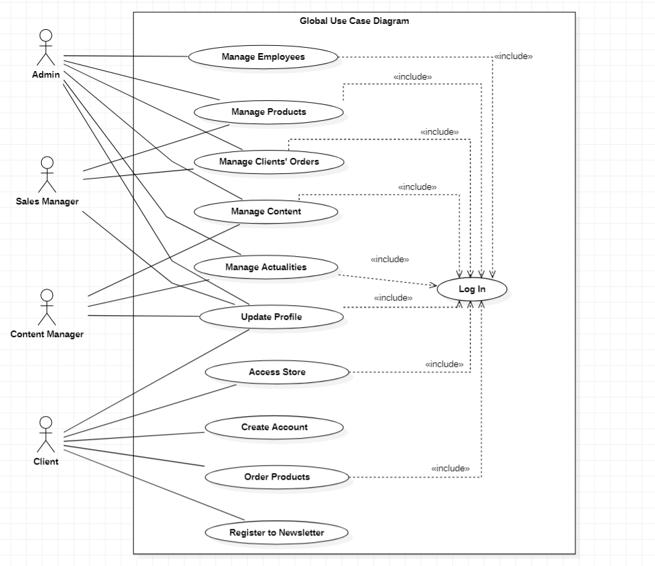

Figure 7: Global Use Case Diagram

## Project management with Scrum

In this part we will identify the SCRUM roles, then, we will identify the functionalities of the Product Backlog.

#### SCRUM roles

The Scrum team consists of a product owner, a Scrum Master and the development team.

The Scrum team that participated in the realization of this project is defined as follows:

* Product Owner: Mr. Mohamed DHAOUEFI the CEO of CureBionics, He defines the needs of users and the goals that should be achieved by this web application.
* SCRUM Master: Mme Jihene TOUNSI, she’s monitors the progress of the web application in the development phase. She also organizes the SCRUM meetings and explains the concepts of the agile method.
* SCRUM Team: Our Team consists of one developer, Hamdi BOUZAYANE, who’s responsible of distributing the sprints as well as their realization.

#### Product Backlog functionalities

This part is dedicated to the description of the product backlog built according to our application requirements

Table 3: this table describes the product backlog of this project [3]

|  |  |  |
| --- | --- | --- |
| User | User Story | Priority |
|  | As an admin, I want to manage my employees and set their roles | 5 |
|  | As an admin, I want to manage the products in the online store | 6 |
| Admin | As an admin, I want to manage clients’ orders | 8 |
|  | As an admin, I want to manage the content of the web application | 9 |
|  | As an admin, I want to manage the actualities in the News page | 10 |
|  | As an admin, I want to manage the content of the newsletter | 12 |
| Sales Manager | As a sales manager, I want to manage the products in the online store | 6 |
|  | As a sales manager, I want to manage clients’ orders | 8 |
|  | As a content manager, I want to manage the content of the web application | 9 |
| Content Manager | As a content manager, I want to manage the actualities in the News page. | 10 |
|  | As a content manager, I want to manage the content of the newsletter | 12 |
|  | As a Client, I want to create an account | 1 |
|  | As a client, I want to visit the homepage and visit Different functions provided by the web app | 2 |
|  | As a client, I want to browse all the products. | 3 |
| Client | As a client, I want to register for the newsletter without creating an account | 11 |
|  | As a client, I want to update my password and my personal information | 4 |
|  | As a client, I want to order products and register for a Bionic arm. | 7 |

TABLE 3: Product Backlog

#### Global Use Case Diagram

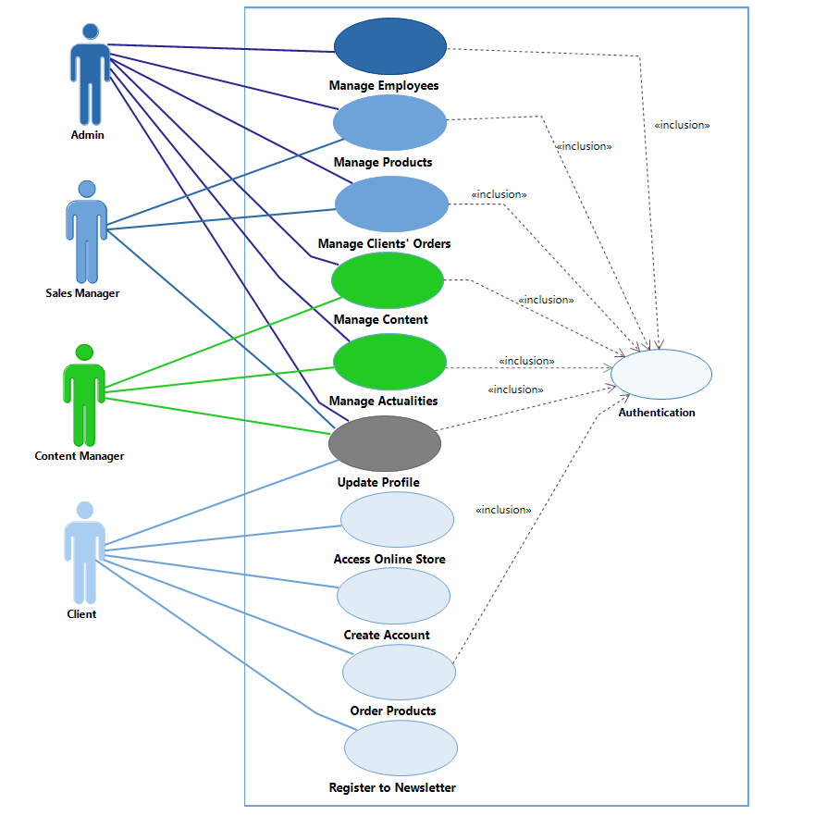 Global Use Case Diagram Figure [8]:

Figure 7: Global Use Case Diagram

#### Sprints Planning

After developing the product backlog, we can plan our sprint and set an approximate time frame for completing the progress. The project is divided into 4 sprints, at the beginning of each variable there is a fixed estimated time.

## Models and Design

Within the framework of an IT project, the creation of mock-ups modeling the application interfaces is a very important phase since the client needs to see something concrete, The interface models communicate and better explain how the application works, allowing customers to decide whether or not it is exactly what they are looking for, we used Photoshop to create a primary design of our web application and these are some of the designs we created.

Figure 8 shows the distribution of sprints in our project

Figure 8: Sprints Distribution

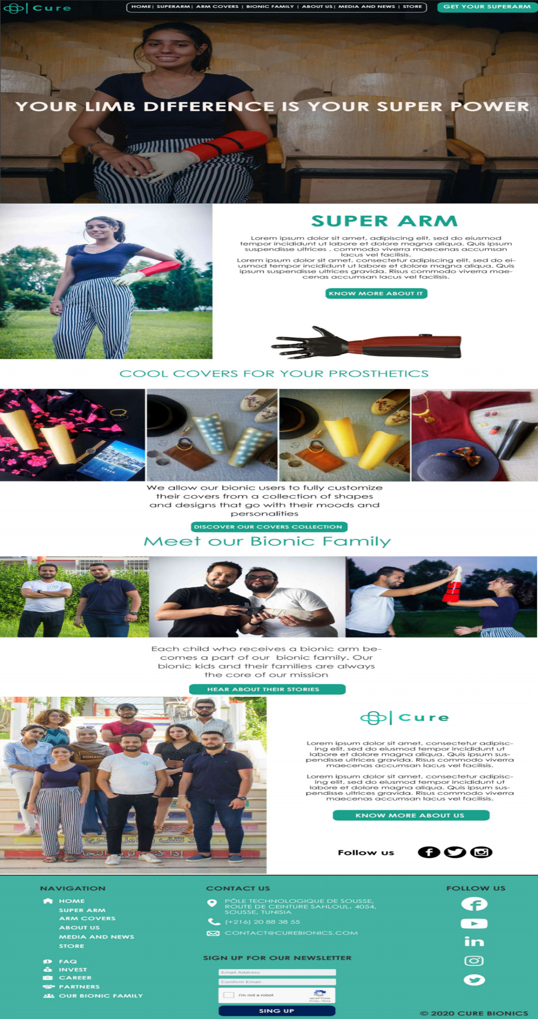

Figure 9: shows the different components of the home page.

Conclusion

At the beginning of this chapter, the functional and non-functional needs were specified and the actors were identified. Subsequently, the work team was presented, then the Product Backlog was created and the project sprints were planned. In addition, we shared the interfaces design of our web application and presented the hardware and software environment used during the realization of the project before describing the general architecture of the application. Finally, we presented the static logical viewpoint and the physical infrastructure of the system through the global class diagram and the deployment diagram.

* In the next chapter, we'll start the development of the first sprint.

# Chapter 4: Study and realization of Sprint 1

**Plan :**

## Sprint 1 Backlog

## Functional Specifications

## Design

## Realization

## Tests

## Presentation of Sprint 1 monitoring tools

# Chapter 4: Study and realization of Sprint 1

Introduction

This chapter focuses on the common functionalities between the simple site visitor and the customer who has an account. The realization of the first sprint divided into five stages: Functional specification, design, execution, testing and retrospective.

## Sprint 1 Backlog

|  |  |  |  |
| --- | --- | --- | --- |
| Priority | User Story | Task | Estimation |
|  | As a client, I want to visit the navigate the whole app | Develop the Home page Template | 2 |
| 3 |  | Develop the Navbar of the web application. | 1 |
|  |  | Develop the Footer of the web application. | 1 |
| 4 | As a client, I want to browse all the products | Develop the Products category (Shop) page content | 4 |
|  |  | Develop the Products Display page | 3 |
| 1 | As a client, I want to create an account | Develop the Signup page | 1 |
| 2 | As a client, I want to sign in to the dashboard of the web application | Develop the Log in page | 1 |
|  |  | Develop the Dashboard Template | 1 |
| 7 | As a client, I want to register for a Bionic Arm | Develop Bionic Arm registration form | 2 |
| 5 | As a client, I want to order a product | Develop order product page content | 3 |
|  |  | Develop Cart page content | 3 |
| 6 | As a client, I want to update my profile | Develop Profile page content | 2 |
|  |  | Develop Update Password page Content | 1 |

TABLE 4: Sprint 1 Backlog

## Functional Specifications

In this part, we will state the different functionalities of sprint 1 through the use case diagram. Then, we will present the scenarios of some use cases through textual descriptions.

#### Use Case Diagram

Figure 14: represents the customer use case diagram

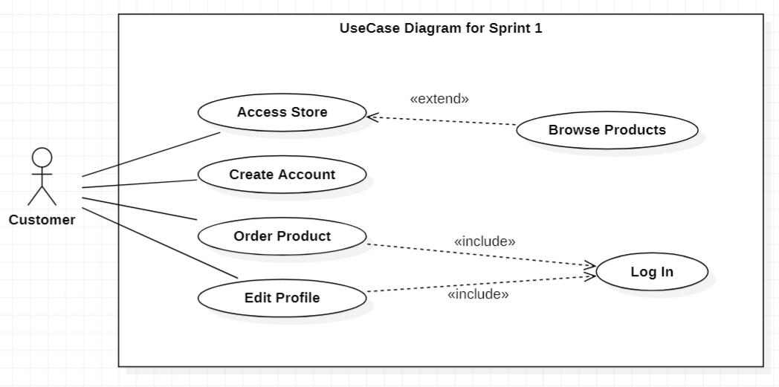

Figure 14: Use case diagram

#### Use cases textual description

In this section we will present some use cases, specify the requirements for each one, and specify their different scenarios and results

##### Textual description of use case “Create an account”

|  |  |
| --- | --- |
| Title | Create Account |
| Summary | This use case allows the client to create an account |
| Principal Actors | Customer |
| Pre-condition | The Customer access to signup form |
| Post-condition | The Customer becomes a Client. |
| Basic Scenario | 1. The customer fills his personal information 2. The system verifies the submitted information 3. The system adds the account to the database 4. The system returns to the login page |
| Alternative Scenario | 1.1 : Personal information submitted by the customer were not valid  a. the system displays an error message  b. return to step (1)  2.1 : username or email is already in use  a. the system displays an error message  b. return to step (1) |
|  |  |

##### Textual description of use case “Login”

|  |  |
| --- | --- |
| Title | Login |
| Summary | This use case allows the client to update his personal information |
| Principal Actors | User |
| Pre-condition | The User has an account |
| Post-condition | The User Login to Dashbord. |
| Basic Scenario | 1. The customer clicks on log in 2. The system shows the log in page 3. The customer fills username and password 4. The system verifies the submitted information 5. The system grants the customer the access to the dashboard 6. The system takes customer to the Dashbord page |
| Alternative Scenario | 3.1 : username or password is wrong  a. the system displays an error message  b. return to step (3) |
|  |  |

##### Textual description of use case “Order a product”

|  |  |
| --- | --- |
| Title | Order a product |
| Summary | This use case allows the client to order a product |
| Principal Actors | Customer |
| Pre-condition | The Customer has an account. |
| Post-condition | The Customer receives updates about his order. |
| Basic Scenario | 1. The customer access to the shop 2. The customer choses a product category 3. The system displays the available types of the selected category 4. The customer choses a type 5. The system takes the customer to product display page 6. The customer choses side and size of product 7. The customer clicks to add the product to cart 8. The system takes customer to cart 9. The customer clicks on checkout 10. The system displays a success message 11. The system takes customer back to Home page |
| Alternative Scenario | 9.1 : client click on continue shopping |
|  | a. the system returns to step (3) |

## Design

In this part we will present the sequence diagrams of the use cases already described above and we will present the class diagram of this sprint.

#### Detailed sequence diagram

Because of the analogy made between the REDUX architecture and the MVC architecture in the previous chapter, it was decided to construct a sequence diagram based on the MVC model to simplify them. In this section, we will introduce a sequence diagram for the following use case: "Create Account", “Order Products”, and “Update Profile”.

##### Sequence diagram of the use case "Create an account"

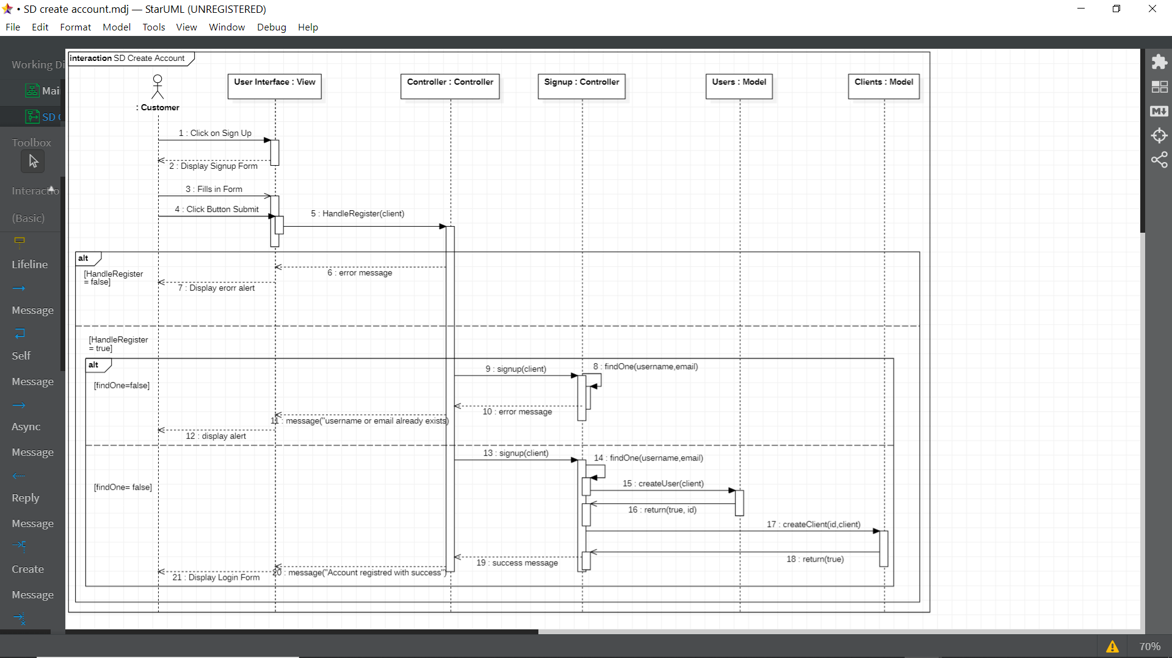

Figure 15: Sequence Diagram <<Create Account>>

##### Sequence Diagram of the use case “Login”

Figure 16: Sequence Diagram <<Login>>

##### Sequence Diagram of the use case “order product”

Figure 17: Sequence Diagram <<Order product>>

>>

Figure 17: Sequence Diagram <<Order product>>

#### Class Diagram

In this part, we will present the classes of Sprint 1, then, we will present the corresponding models in our application.

##### Classes presentation

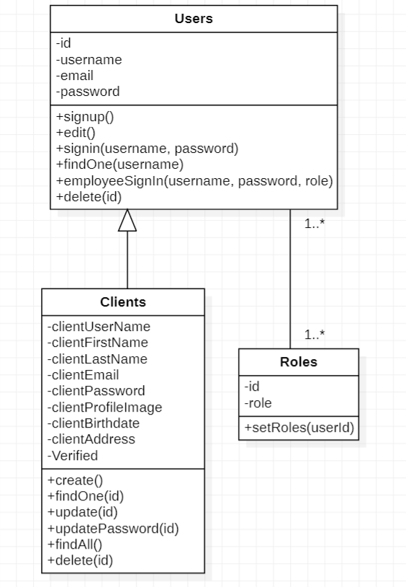 The class diagram for this sprint includes three classes and an entity class the client class with all of the client’s personal information, the users class that has the only the login information of the client, and the role class where the entity comes between the users class and the roles class because of the many to many association.

Figure 16: Class Diagram Sprint 1

##### Database models

**MySQL** is a freely available open source Relational Database Management System that uses Structured Query Language called SQL which’s the most popular language for adding, accessing and managing content in a database.

We used Sequelize to make creating MySQL models easier and faster.

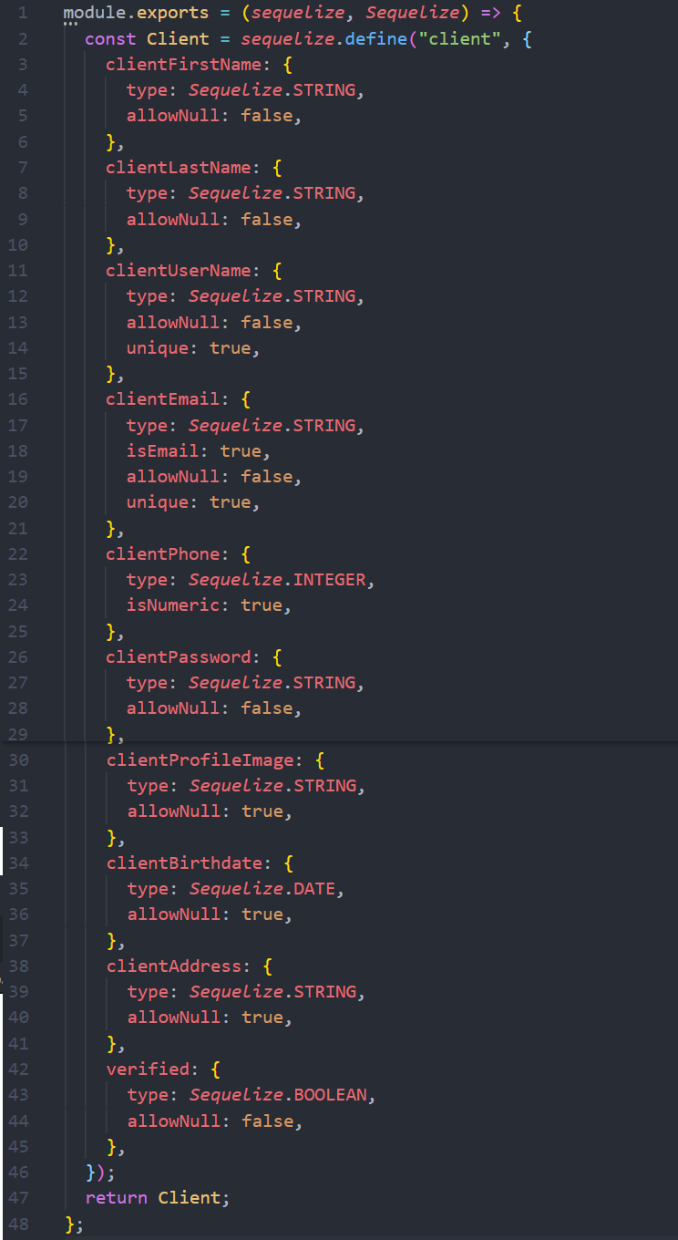

Figure 17: Clients Class Model

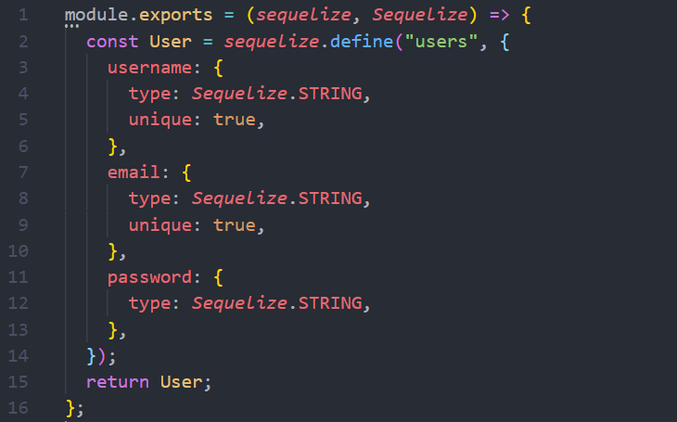

Figure 18: Users Class Model

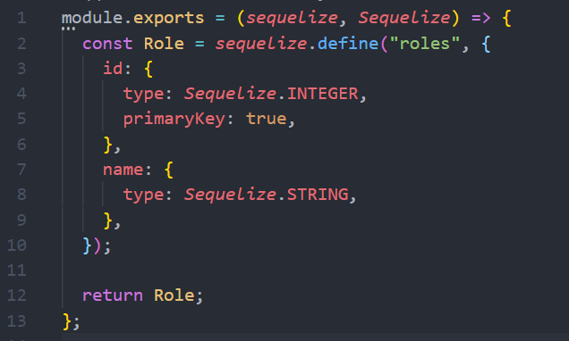

Figure 19: Roles Class Model

##### Relational model

* Users(**id**, username, email, password)
* roles(**id**, role)
* users_roles(#**userId**, #**roleId**)
* clients(**id**, clientFirstName, clientLastName, clientUsername, clientBirthdate, clientEmail, clientPassword, clientProfileImage, clientAddress, verified)

## Realization

This part is dedicated to the presentation of some interfaces developed during this sprint. We have chosen to present the following interfaces: “Shop page”, “Product manager page”, “Profile page” and “create account page”

#### UI Product manager

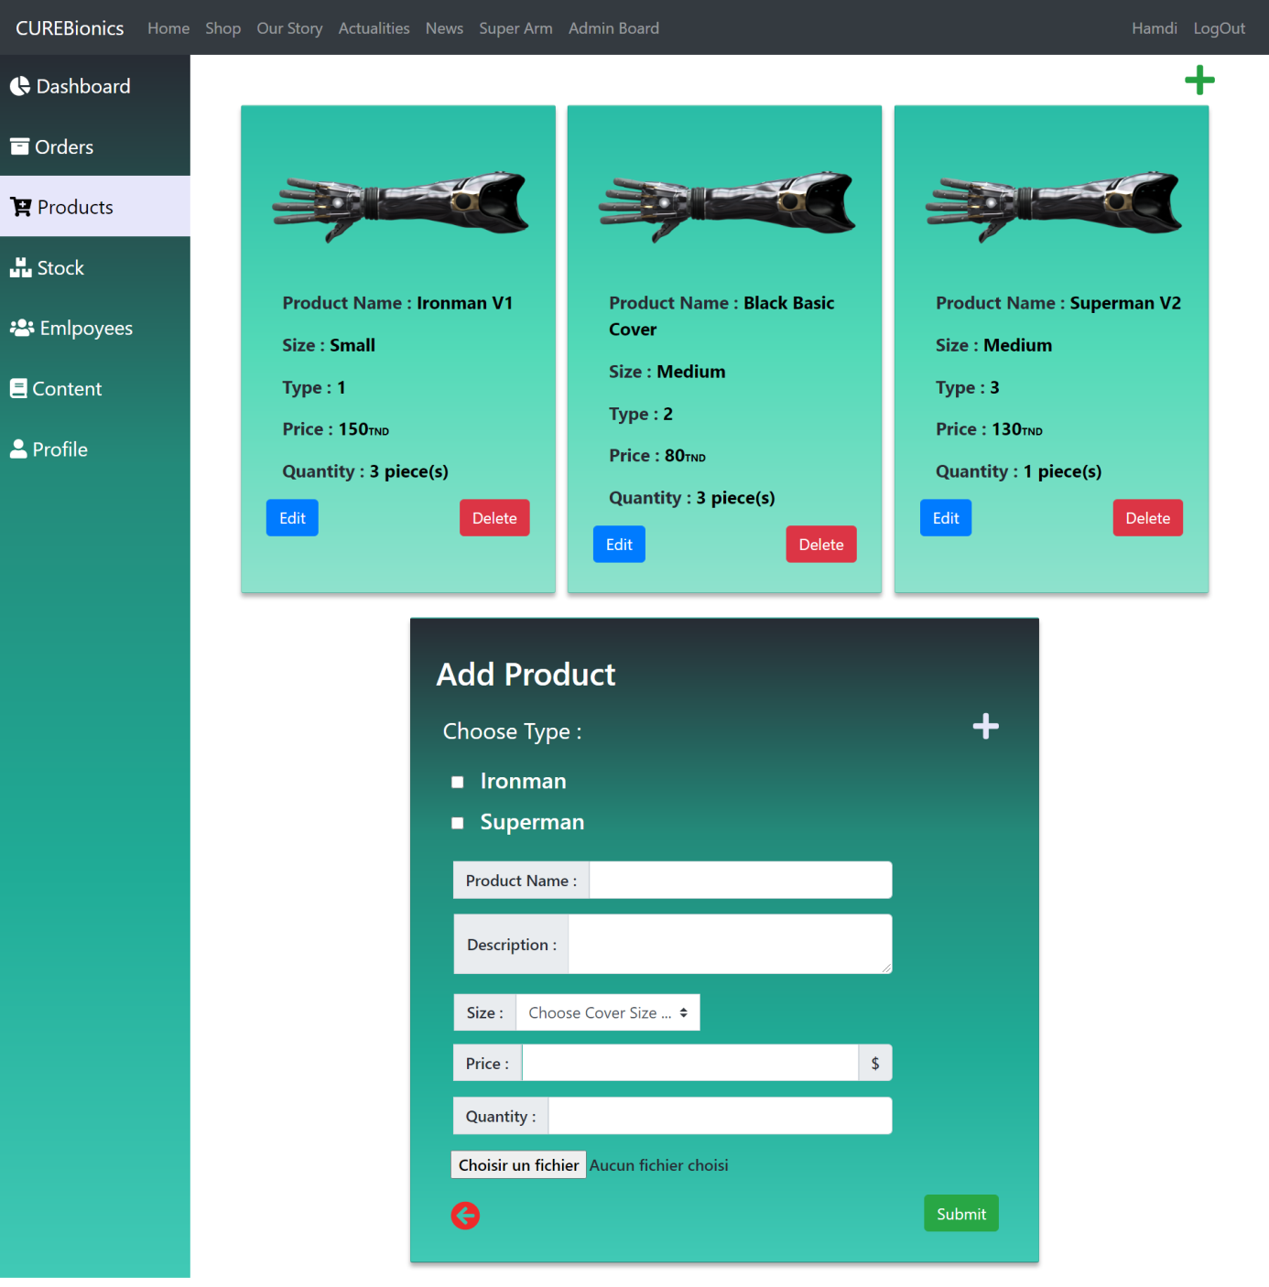

#### UI Shop

#### UI user profile

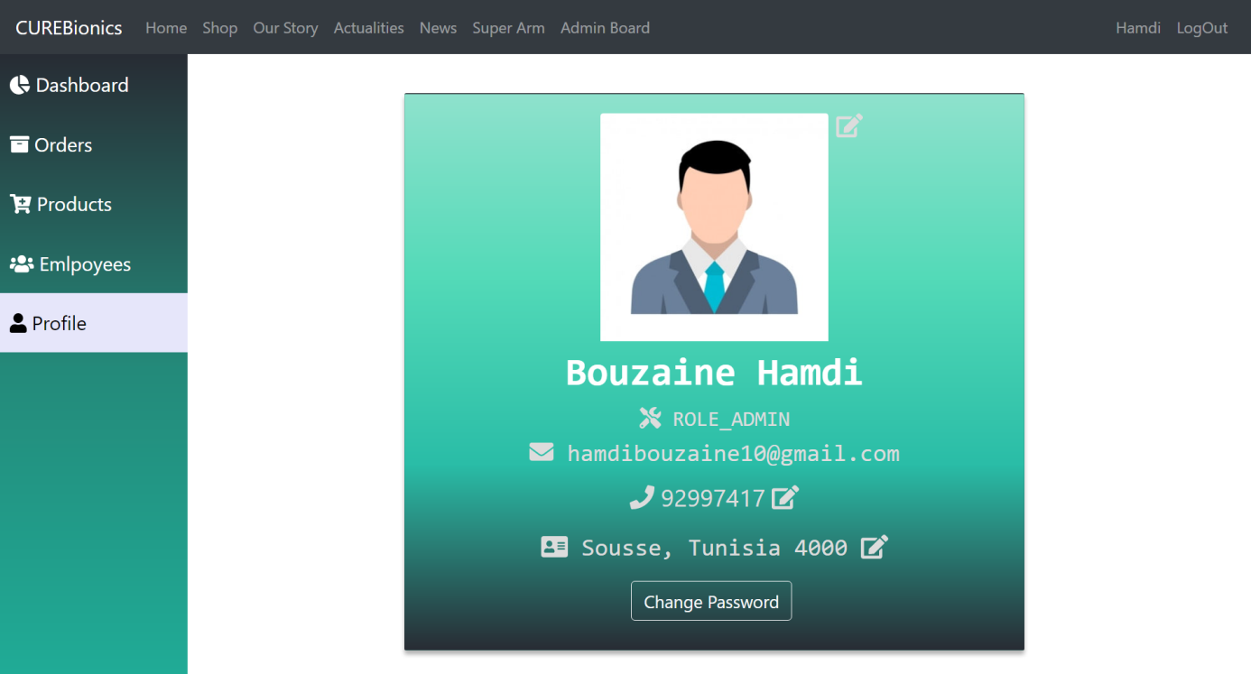

#### UI create Account

#### 

## Tests

In the SCRUM method, the test phase is indispensable. Indeed, before the end of each sprint, all developed functionalities must be tested by the development team and validated by the Product Owner in order to guarantee an optimal quality of the product.

|  |  |  |  |  |
| --- | --- | --- | --- | --- |
| Use Case | Given | When | Then | Result |
| Create Account | The user is in the Sign Up page of the client area | The user fills in the registration form and validates his personal information | All input checks are carried out. | success |
|  |  |  | The user is registered in the database |  |
| Update Profile | The user is in the Profile page | The customer logs into the dashboard | The system display the profile information | success |
|  |  |  | The updates registered in the database |  |
| Order Product | The user is in the shop | The user choses product category and choses the product details | The order registered in the database | success |

TABLE 5: Sprint 1 Tests

## Presentation of Sprint 1 monitoring tools

In this part, we will present the Scrum Board and the Burndown Chart of this sprint.

#### Sprint 1 Scrum Board

This is a board that allows you to follow the progress of the Sprint Backlog tasks in progress, It consists of three columns: To Do, Doing, and Done.

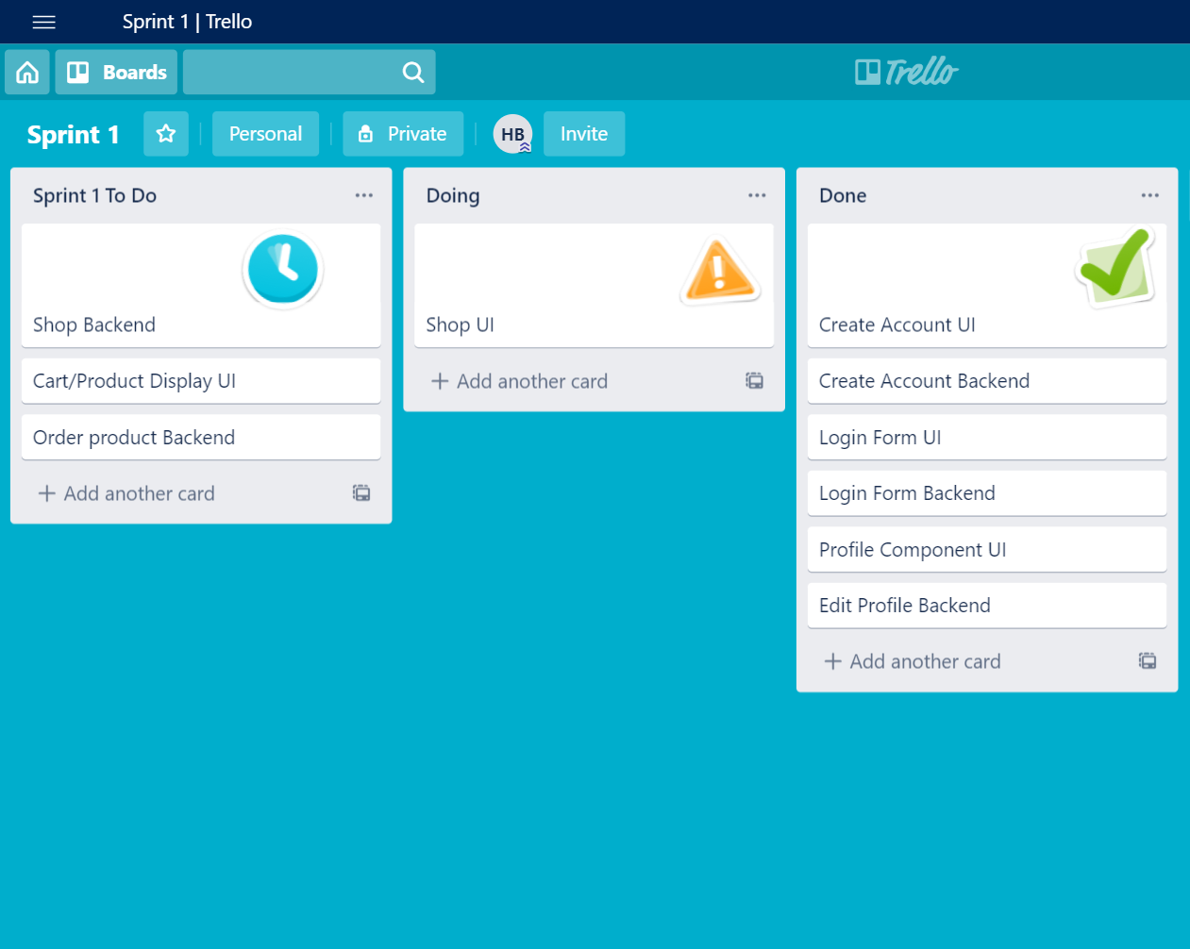

#### Sprint1 Burndown Chart

Burndown chart here

Conclusion

In this chapter, we introduced the first sprint through four steps, namely: Functional Specifications, design, realization and testing.

* In the next chapter, the second sprint will begin.

# Chapter 5: Study and realization of Sprint 2

**Plan :**

## Sprint 2 Backlog

## Functional Specifications

## Design

## Realization

## Tests

## Presentation of Sprint 2 monitoring tools

# Chapter 5: Study and realization of Sprint 2

Introduction

In this part, we will state the different functionalities of sprint 2 through the use case diagram. Then, we will present the scenarios of some use cases through textual descriptions

## Sprint 2 Backlog

|  |  |  |  |
| --- | --- | --- | --- |
| Priority | User Story | Task | Estimation |
|  |  | Develop the Admin board page in dashboard | 2 |
|  |  | Develop the Employee manager Component | 1 |
|  | As an Admin, I want to add employees and set their roles to do specific things in the web application based on the role they have | Develop the signup employee page | 1 |
|  |  | Develop the Edit employee role component |  |
|  |  | Develop the Delete employee Component |  |
|  |  | Develop the Products manager Component | 4 |
|  | As an Admin and a Sales Manager, I want to manage the products | Develop the add product component | 3 |
|  |  | Develop the edit product component |  |
|  |  | Develop the delete product component |  |
|  |  | Develop the Clients’ orders component | 1 |
|  | As an Admin and a Sales Manager , I want to see and manage clients orders | Develop the edit order component |  |
|  |  | Develop the delete clients order component |  |

## Functional Specifications

In this part, we will first describe the different functionalities of sprint 2 through the use case diagram. Then, we will present the scenarios of some use cases through textual descriptions.

#### Use Case Diagram

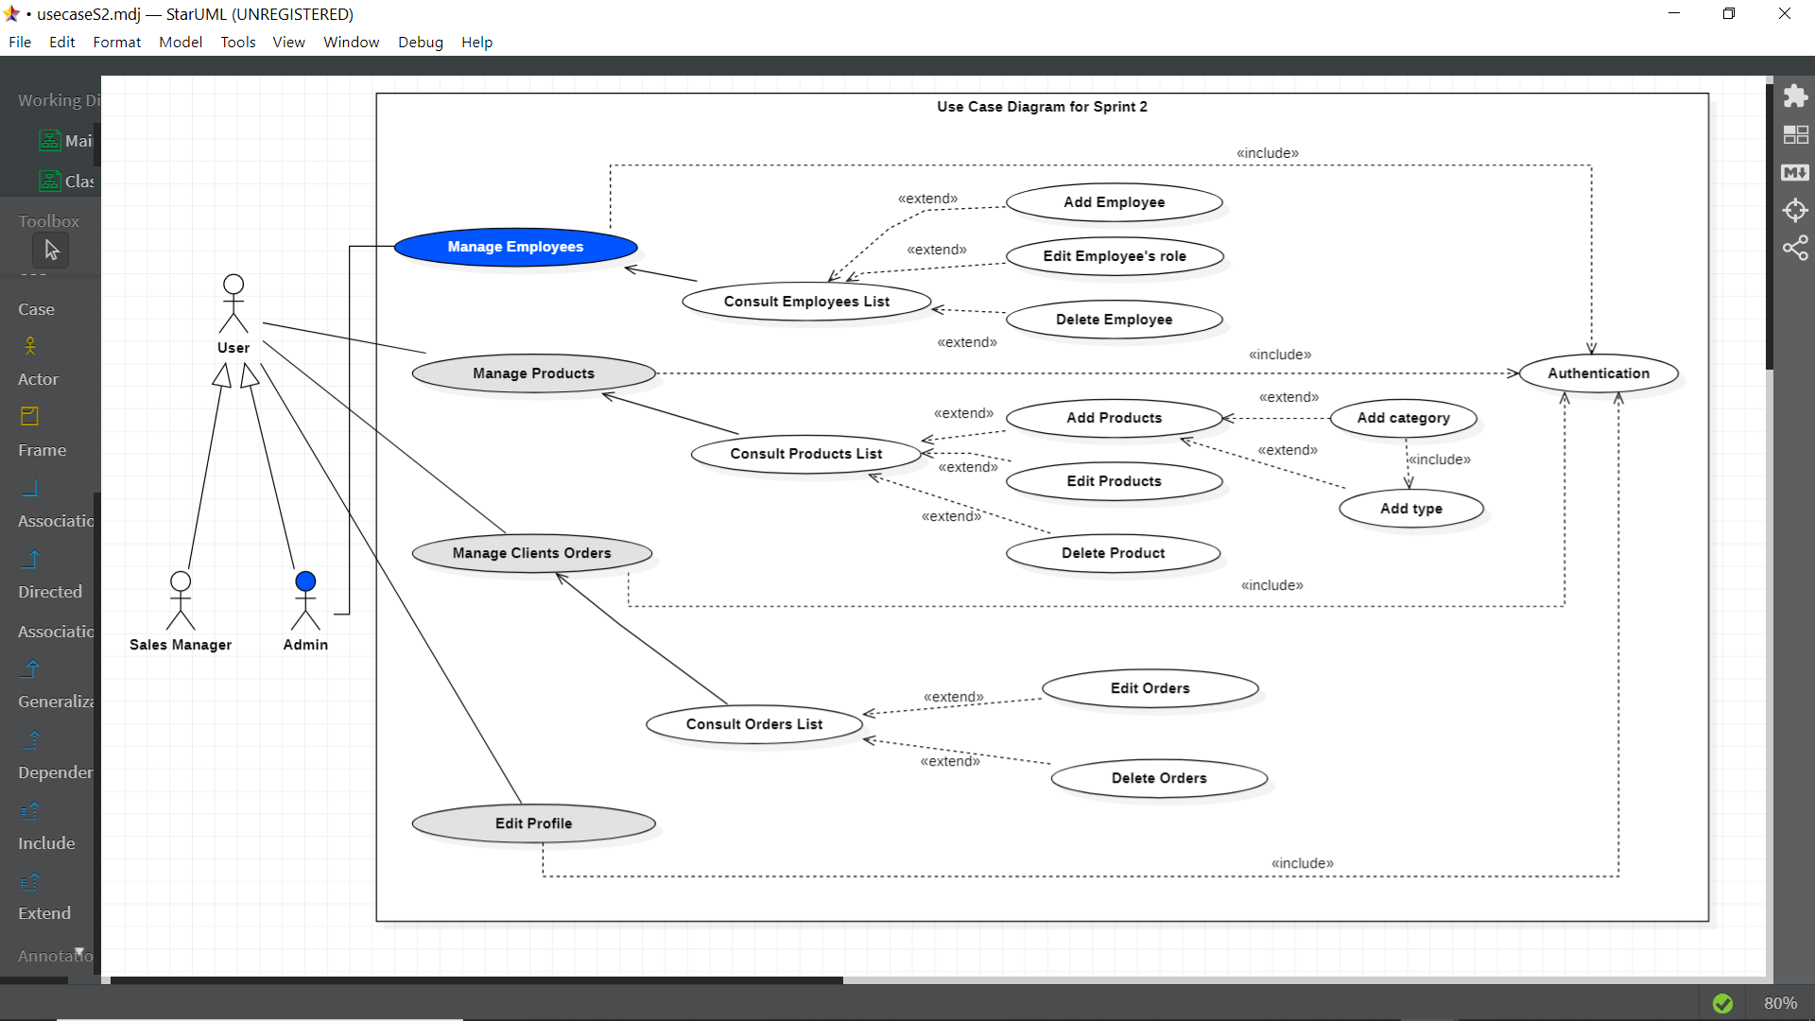 The Figure 20 describes the use case diagram specified for the second sprint

Figure 20: Sprint 2 Use Case diagram

#### Use cases textual description

After explaining the different use cases, we will go into detail about some of them through textual descriptions.

##### Textual description of use case “Edit Employees’ role”

|  |  |
| --- | --- |
| Title | Edit Employee’s Role |
| Summary | This use case allows the Admin to manage employees’ role |
| Principal Actors | Admin |
| Pre-condition | The Admin logs into the Dashboard. |
| Post-condition | The Employee has a new role in the web application |
| Basic Scenario | 1. The admin logs into the Dashboard 2. The admin clicks on employees in sidebar menu 3. The system display the list of the registered employees in database 4. The admin browse the employees list 5. The admin choses the employee to edit his role 6. The admin click on edit 7. The system display the edit employee component 8. The admin choses the new role 9. The admin clicks on save 10. The system saves the new updates to the database. |
| Alternative Scenario | 9.1 : the admin click on cancel  a. the system cancels changes  b. the system hides the edit employee component |

##### Textual description of use case “Add Products”

|  |  |
| --- | --- |
| Title | Edit Employee’s Role |
| Summary | This use case allows the Admin and the Sales Manager to add new products to the store |
| Principal Actors | Admin, Sales Manager |
| Pre-condition | The Admin or the Sales manager logs into the Dashboard. |
| Post-condition | The Store has new products |
| Basic Scenario | 1. The admin logs into the Dashboard 2. The admin clicks on products in sidebar menu 3. The system display the manage products component 4. The admin clicks on add product 5. The system display the Add product component 6. The admin choses a category 7. The admin click on next 8. The system display a form with the available types for the chosen category and other input fields for product details 9. The admin selects a type 10. The admin fills in the form 11. The admin clicks on save 12. The system saves the new product to the database. 13. The system refreshes page to display products |
| Alternative Scenario | 6.1 : the admin clicks on add new category  a. the system display add new category component  b. the admin fills in the new category details  c. the admin clicks on add  d. the system adds the new category to database  e. the system display add product form with an input filed designed for the new type  f. the system takes back user to step (10) |

##### Textual description of use case “Edit Orders”

|  |  |
| --- | --- |
| Title | Edit Client’s Orders |
| Summary | This use case allows the Admin and Sales manager to edit Orders |
| Principal Actors | Admin, Sales Manager |
| Pre-condition | The Admin or Sales manager logs into the Dashboard. |
| Post-condition | The Employee has a new role in the web application |
| Basic Scenario | 1. The user logs into the Dashboard 2. The user clicks on orders in sidebar menu 3. The system display the list of the orders registred in database 4. The user browse the orders list 5. The user choses the order to edit 6. The user click on edit 7. The system display the edit orders component 8. The user selects the new status 9. The user clicks on save 10. The system saves the new updates to the database. |
| Alternative Scenario | 9.1 : the user click on cancel  a. the system cancels changes  b. the system hides the edit orders component |

## Design

In this part we will present the sequence diagrams of the use cases already described above and we will present the class diagram of this sprint.

#### Detailed sequence diagram

In this part, we will present the sequence diagrams of the following use cases: “Edit Employee’ roles”, “Add products” and “Edit Orders”

##### Sequence diagram of the use case "Edit Employee’s Role"

We decided to create roles for employees to make work easier for the admin, for example he can give an employee one of two roles, Sales manager we has the access to all the e-commerce activities in our web application or Content manager, this role gives access to editing the content of our web application and with this the admin can give access to specified parts of the dashboard.

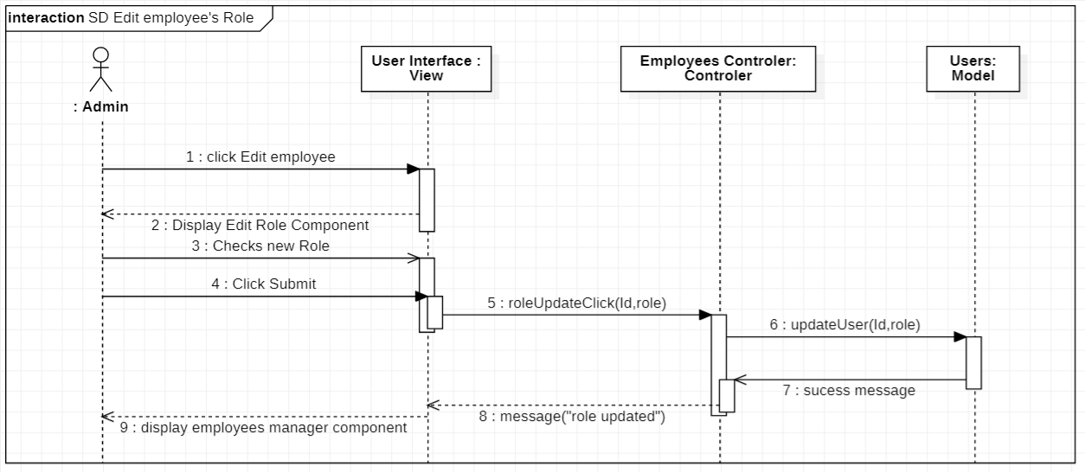

##### Sequence diagram of the use case "Edit Orders"

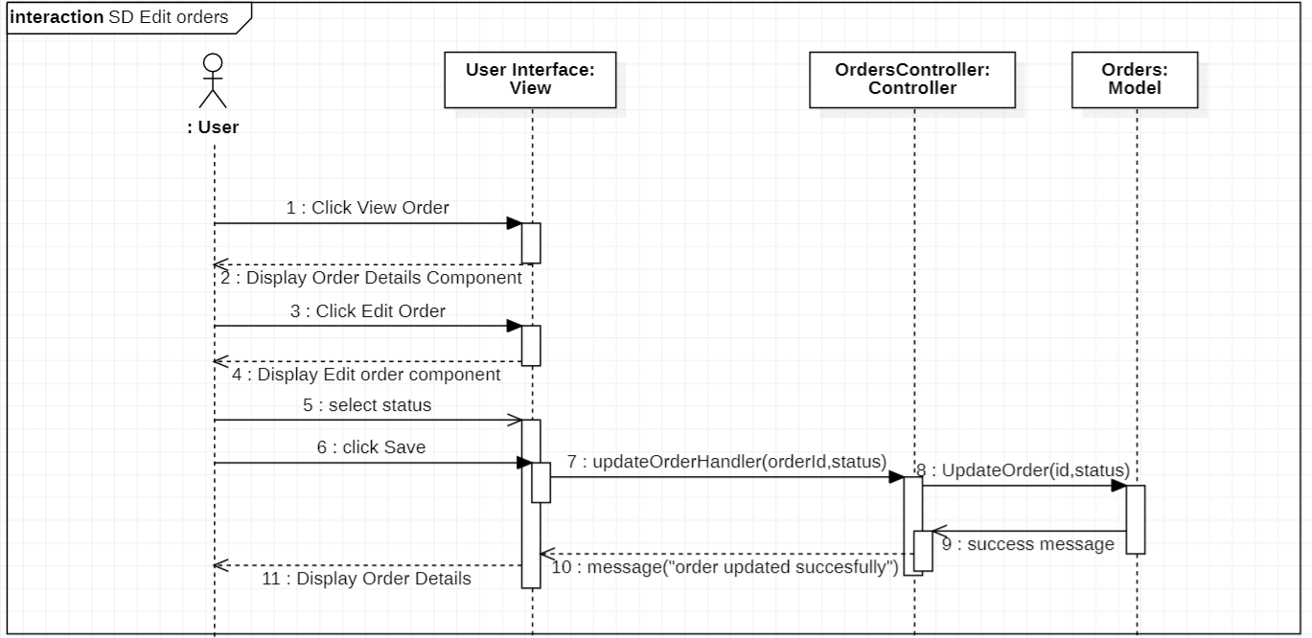

##### Sequence diagram of the use case "Add Products"

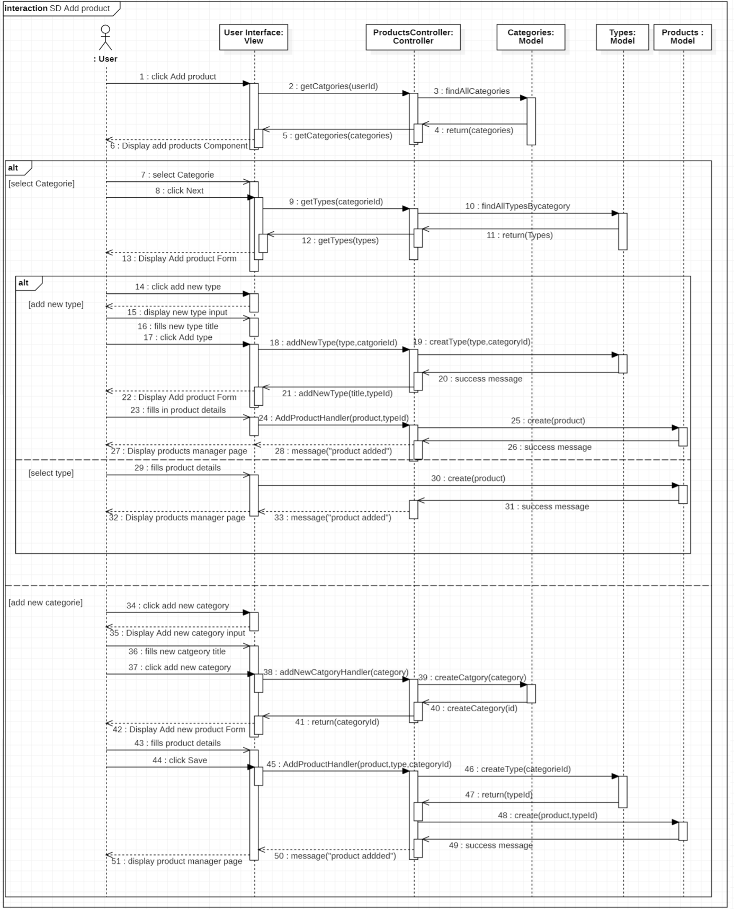

#### Class Diagram

In this part, we will present the classes of Sprint 2 based on the Use cases we mentioned above, then, we will present the corresponding models in our application.

##### Classes presentation

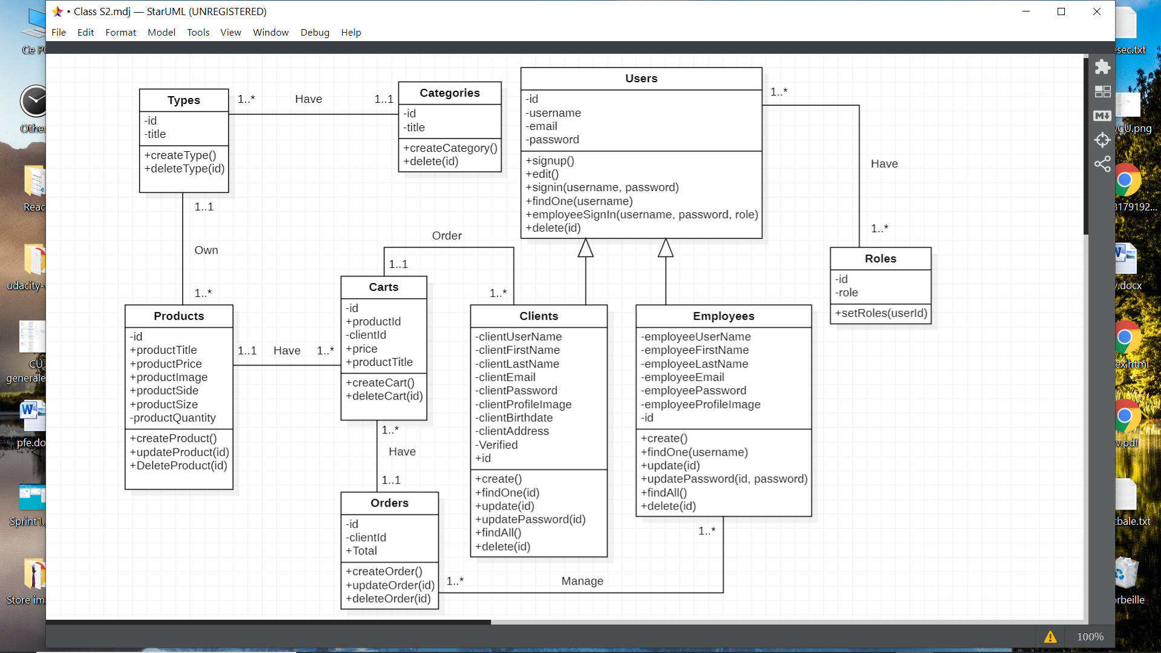The class diagram for this sprint includes nine classes and each class describes a model from the second sprint in our application in the next figure we can find also the associations and the relations between the classes

##### Database models

Figure ?? shows the models of the Class category. It contains the attributes of this collection as well as their types and the constraints applied to each attribute.

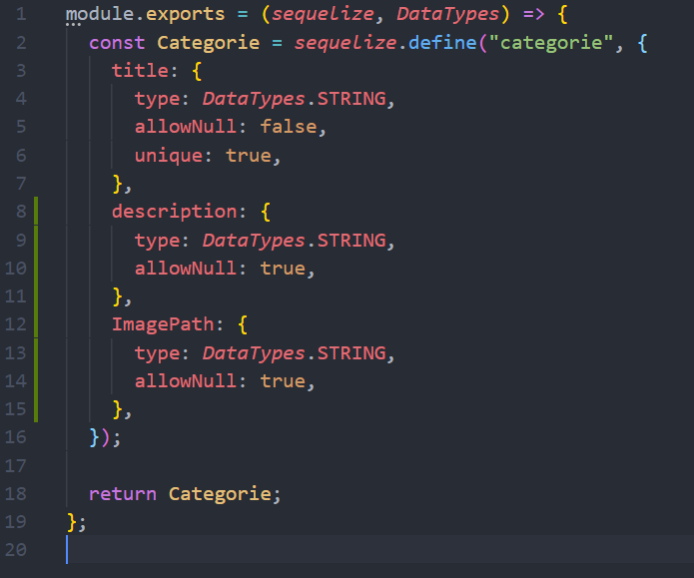

Figure ??: Class Categories Model

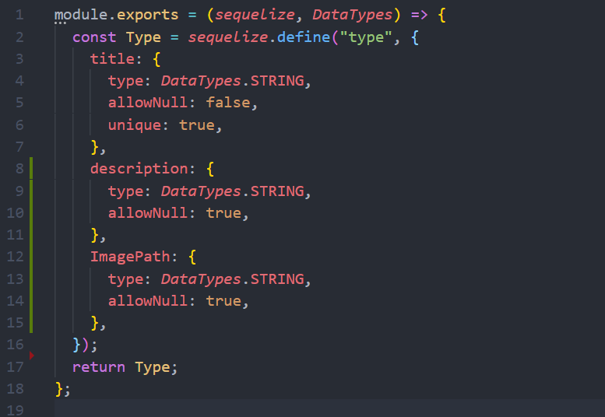Figure ?? shows the models of the Class type. It contains the attributes of this collection as well as their types and the constraints applied to each attribute.

Figure ??: Class Types Model

Figure ?? shows the models of the Class products. It contains the attributes of this collection as well as their types and the constraints applied to each attribute.

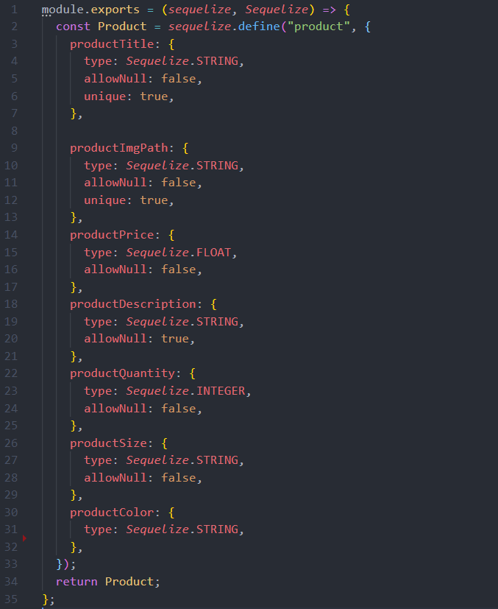

Figure ??: Class Products Model

Figure ?? shows the models of the Class employees. It contains the attributes of this collection as well as their types and the constraints applied to each attribute.

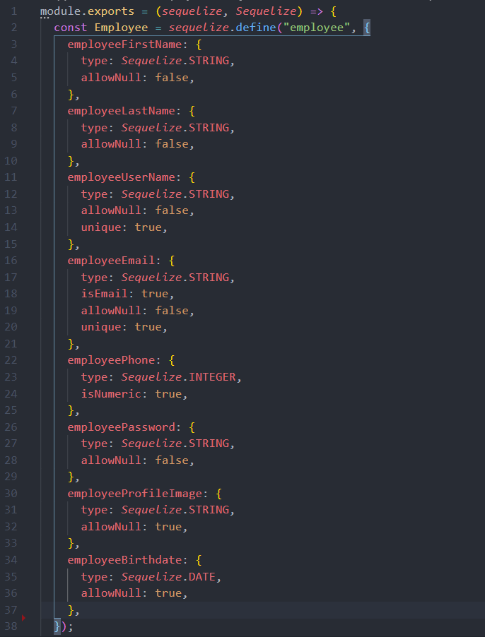

Figure ??: Class Employees Model

##### Relational model

* Categories(**id**, title, description, imagePath)
* Types(**id**,title,description, imagePath, #**categorieId**)
* Products(**id**, productTitle, productImgPath, productPrice, productDescription, productQuantity, productSize, productColor, #**typeId**)
* employees(**id**, employeeFirstName, employeeLastName, employeeEmail, employeePassword, employeeProfileImage, employeeUsername)
* Users(**id**, username, email, password)
* roles(**id,** role)
* users_roles(#**userId**, #**roleId**)
* clients(**id**, clientFirstName, clientLastName, clientUsername, clientBirthdate, clientEmail, clientPassword, clientProfileImage, clientAddress, verified)
* orders(**id**, clientId, total)
* carts (**id**, #**clientId,** #**productId**, productTitle, price, quantity, total, #**orderId**)

|  |  |  |  |  |
| --- | --- | --- | --- | --- |
|  |  |  |  |  |

## Realization

In this part, we will present some interfaces developed during the second Sprint. We have chosen to present the following interfaces : <<add product>> , <<manage employees>> and <<manage orders>>

#### UI manage products

#### UI Edit product

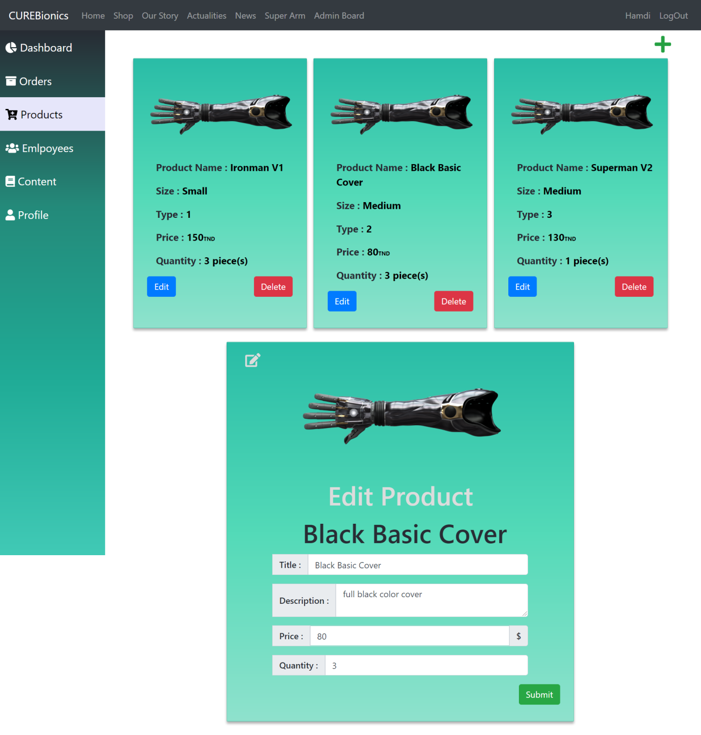

#### UI manage employees

#### 

#### UI manage orders

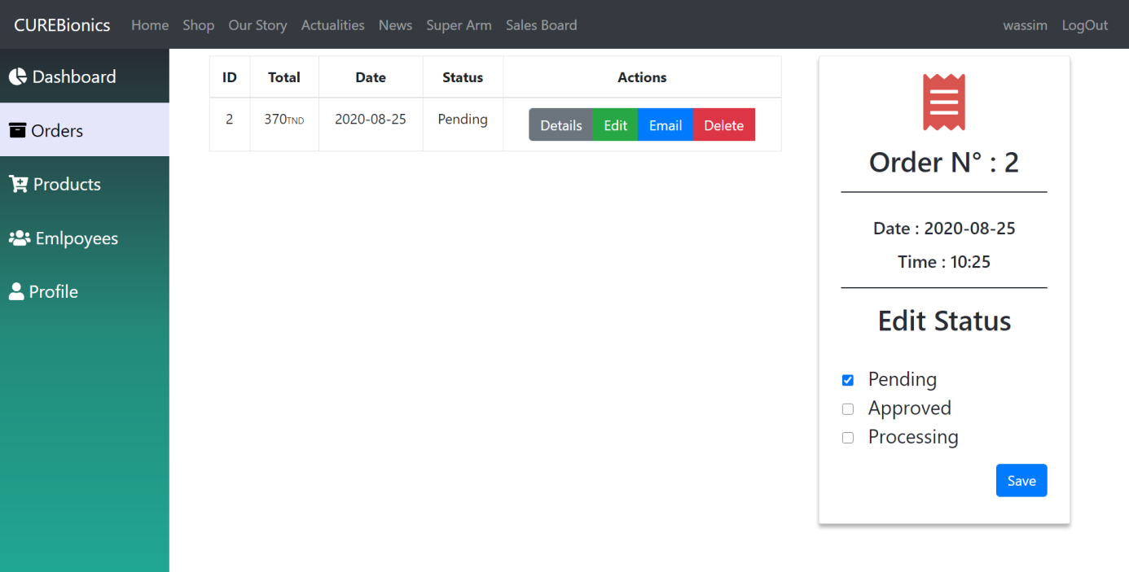

## Tests

|  |  |  |  |  |
| --- | --- | --- | --- | --- |
| Use Case | Given | When | Then | Result |
|  |  |  | The system display the edit employee component |  |
| Edit employee’s role | The admin is in the employees manager component | The admin clicks the edit button in front of the employee whose role he wants to change​​ | The admin checks the designed role | success |
|  |  |  | The admin click on save |  |
|  |  |  | The system updates the employee’s role in the database |  |
|  |  |  | The system display the existing products and an add product button |  |
|  |  |  | The user click on add product button |  |
|  |  |  | The system display add product component |  |
| Add products | The user is in the products manager component | The customer logs into the dashboard and selects to display the products manager component | The user choses a product category | success |
|  |  |  | The user click on next |  |
|  |  |  | The system display a form |  |
|  |  |  | The user fills in the form with product details |  |
|  |  |  | The user click save |  |
|  |  |  | The system saves the new product in the data base |  |
|  |  |  | The system display all the existing orders |  |
|  |  |  | The user clicks on edit |  |
| Manage Clients’ orders | The user is in the clients’ orders component | The customer logs into the dashboard and selects to display the clients orders component | The system display edit order component | success |
|  |  |  | The user changes the order’s status and clicks on save |  |
|  |  |  | The system saves changes to database |  |

## Presentation of Sprint 2 monitoring tools

In this part, we will present the Scrum Board and the Burndown Chart of Sprint 2.

#### Sprint 2 Scrum Board

This is a board that allows you to follow the progress of the Sprint Backlog tasks in progress, It consists of three columns: To Do, Doing, and Done.

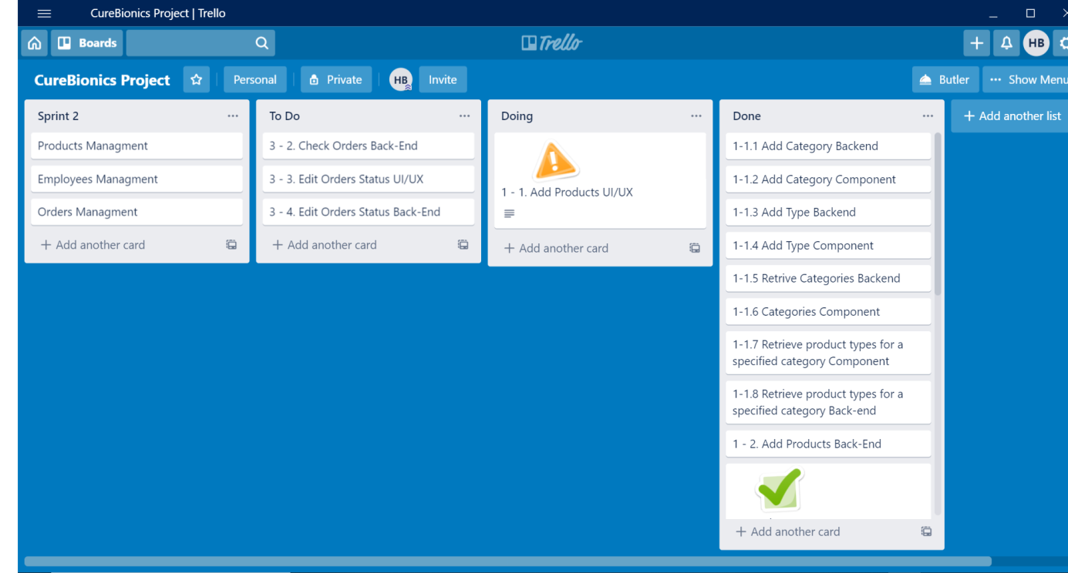

#### Sprint 2 Burndown Chart

BurnDown chart sprint 2

Conclusion

In this chapter, the second sprint was presented. To do so, we went through 4 stages: functional specifications, design, realization and testing.

* In the next chapter, the third sprint will be started.

# Chapter6: Study and realization of Sprint 3

**Plan :**

## Sprint 3 Backlog

## Functional Specifications

## Design

## Realization

## Tests

## Presentation of Sprint 3 monitoring tools

# Chapter 6: Study and realization of Sprint 3

Introduction

In this part, we will state the different functionalities of sprint 3 through the use case diagram. Then, we will present the scenarios of some use cases through textual descriptions

## Sprint 2 Backlog

|  |  |  |  |
| --- | --- | --- | --- |
| Priority | User Story | Task | Estimation(/day) |
|  |  | Develop the content manager Dashbord | 1 |
|  |  | Develop the content manager Component | 1 |
|  |  | Develop the add content component | 1 |
| 1 | As an Admin or a Content Manager, I want to edit blogs and content of specific components in the web application. | Develop the edit content component | 1 |
|  |  | Develop the Delete content Component | 1 |
|  |  | Develop Actualities page | 1 |
|  |  | Develop News page | 1 |
|  |  | Develop the editable components | 1 |
| 2 | As a Client, I want the web application users to register for a newsletter | Develop register to newsletter form | 1 |
|  |  | Setup MailChimp API to register new clients’ emails | 1 |

## Functional Specifications

In this part, we will first describe the different functionalities of sprint 3 through the use case diagram. Then, we will present scenarios of some use cases through textual descriptions.

#### Use Case Diagram

#### Use cases textual description

After explaining the different use cases, we will go into detail about some of them through textual descriptions.

##### Textual description of use case “Add new Content”

|  |  |
| --- | --- |
| Title | Add New Content |
| Summary | This use case allows the Admin and the Content Manager to add new Content to specific component in the web application |
| Principal Actors | Admin, Content Manager |
| Pre-condition | The Admin or the Content manager logs into the Dashboard. |
| Post-condition | Home, News or actualities has new content |
| Basic Scenario | 1. The user logs into the Dashboard 2. The user clicks on content in sidebar menu 3. The system display the manage contents component 4. The user clicks on add content 5. The system display the Add content component 6. The user fills in new content’s details 7. The user click on add 8. The system saves new content in database |
| Alternative Scenario | 7.1 : the admin clicks on cancel  a. the system hides add content component |

##### Textual description of use case “edit Content”

|  |  |
| --- | --- |
| Title | Edit Content |
| Summary | This use case allows the Admin and the Content Manager to edit existing Content of specific component in the web application |
| Principal Actors | Admin, Content Manager |
| Pre-condition | The Admin or the Content manager logs into the Dashboard. |
| Post-condition | Web application has updated content |
| Basic Scenario | 1. The user logs into the Dashboard 2. The user clicks on content in sidebar menu 3. The system display the manage contents component 4. The user selects page 5. The system display content of the selected page 6. The user click on edit 7. The system display edit content component 8. The user fills in new details 9. The user clicks on save 10. The system saves updated content in database |
| Alternative Scenario | 9.1 : the admin clicks on cancel  a. the system hides edit content component |

##### Textual description of use case “edit Content”

|  |  |
| --- | --- |
| Title | Edit Content |
| Summary | This use case allows the Admin and the Content Manager to delete Content from specific component in the web application |
| Principal Actors | Admin, Content Manager |
| Pre-condition | The Admin or the Content manager logs into the Dashboard. |
| Post-condition | Web application content removed |
| Basic Scenario | 1. The user logs into the Dashboard 2. The user clicks on content in sidebar menu 3. The system display the manage contents component 4. The user selects page 5. The system display content of the selected page 6. The user click on delete 7. The system display delete content modal 8. The user clicks on delete 9. The system deletes content from database |
| Alternative Scenario | 8.1 : the admin clicks on cancel  a. the system hides delete content component modal |

## Design

In this part we will present the sequence diagrams of the use cases already described above and we will present the class diagram of the third sprint.

#### Detailed sequence diagram

In this part, we will present the sequence diagrams of the following use cases: “Add new content”, “edit Content” and “delete content”.

##### Classes presentation

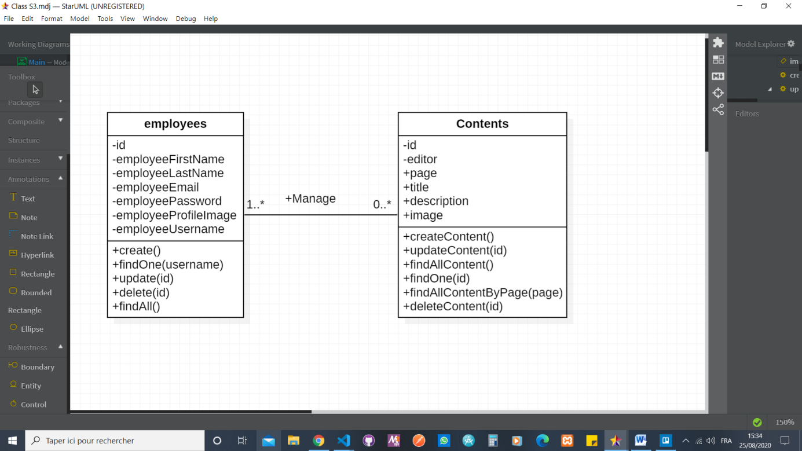 The class diagram for this sprint includes two classes the employees class with all of the employee’s personal information and the contents class that has the details about the specific component’s content in the web application

Figure ??: Class Diagram Sprint 3

##### Database models

As mentioned in first and second sprints we used **Sequelize** to create our **MySQL** database, now we’ll share screenshots of code of the presented classes above.

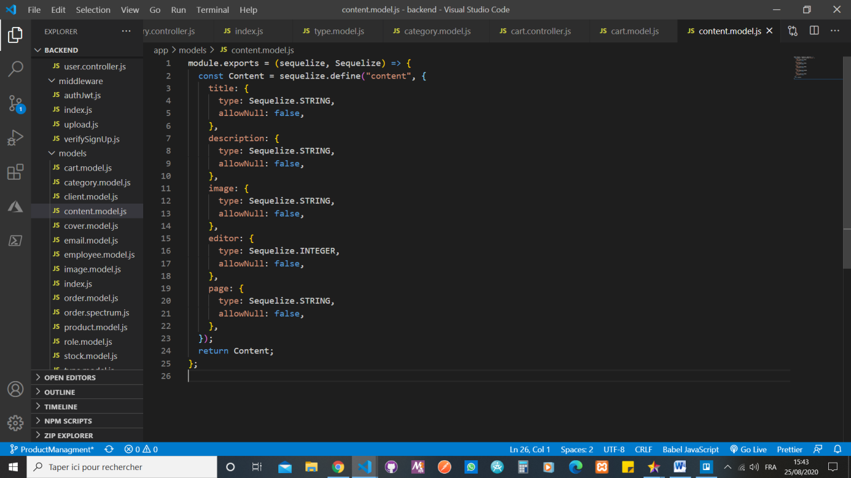Figure ?? shows the models of the Class employees. It contains the attributes of this collection as well as their types and the constraints applied to each attribute.

Figure ??: Contents Class Model

Figure ??: Class Employees Model

##### Relational model

* employees(**id**, employeeFirstName, employeeLastName, employeeEmail, employeePassword, employeeProfileImage, employeeUsername)
* contents(**id**, page, title, description, image, #**editor**)

## Realization

In this part, we will present some interfaces developed during the third Sprint. We have chosen to present the following interfaces : <<add new content>> , <<edit content>> and <<delete content>>

1. 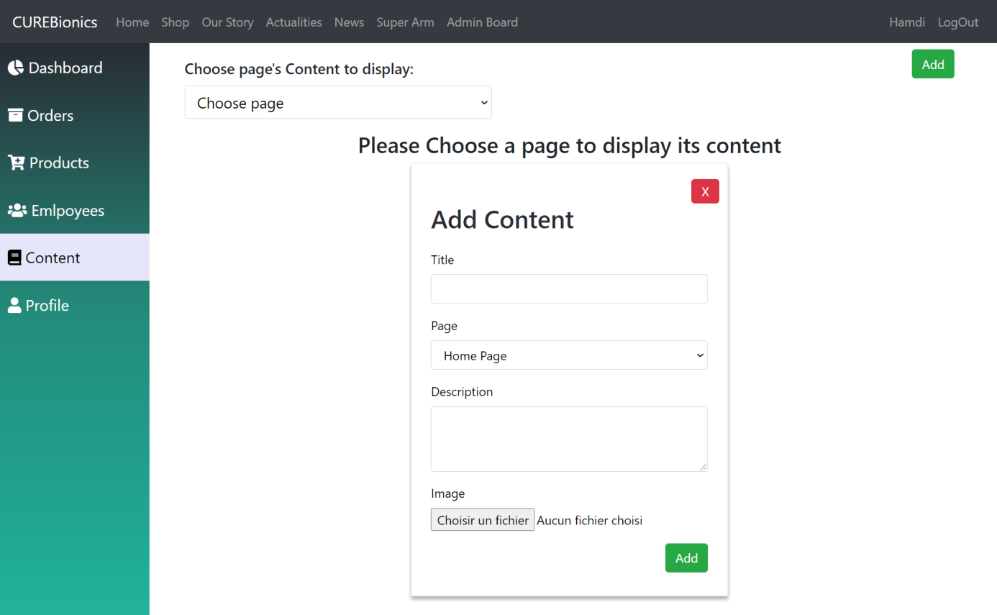

#### UI Add new Content

Figure ??: Add new Content Component

#### UI Edit content

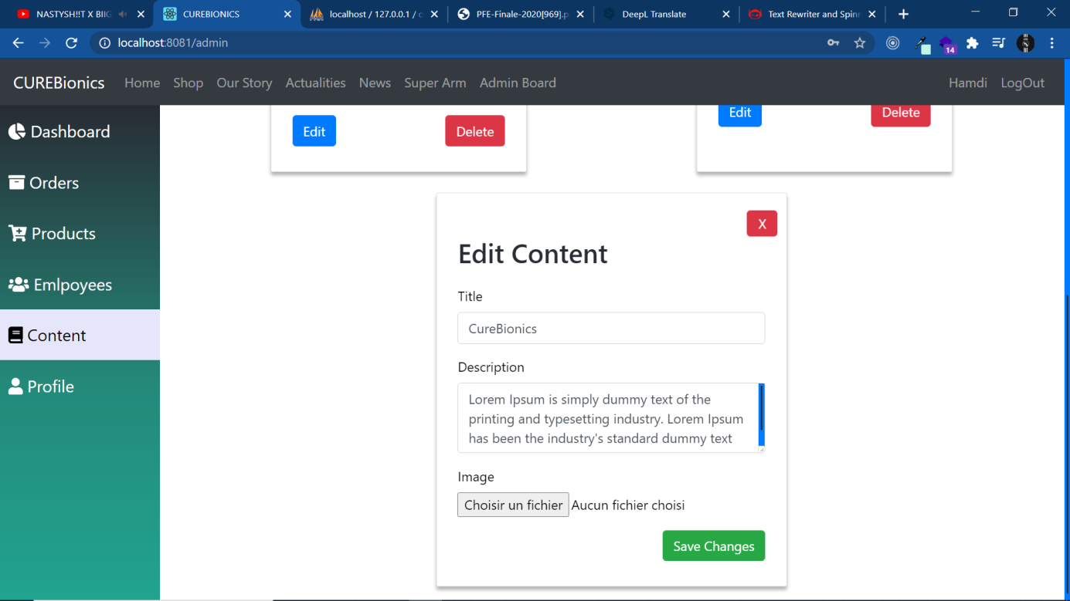

Figure ??: Edit Content Component

#### UI delete content

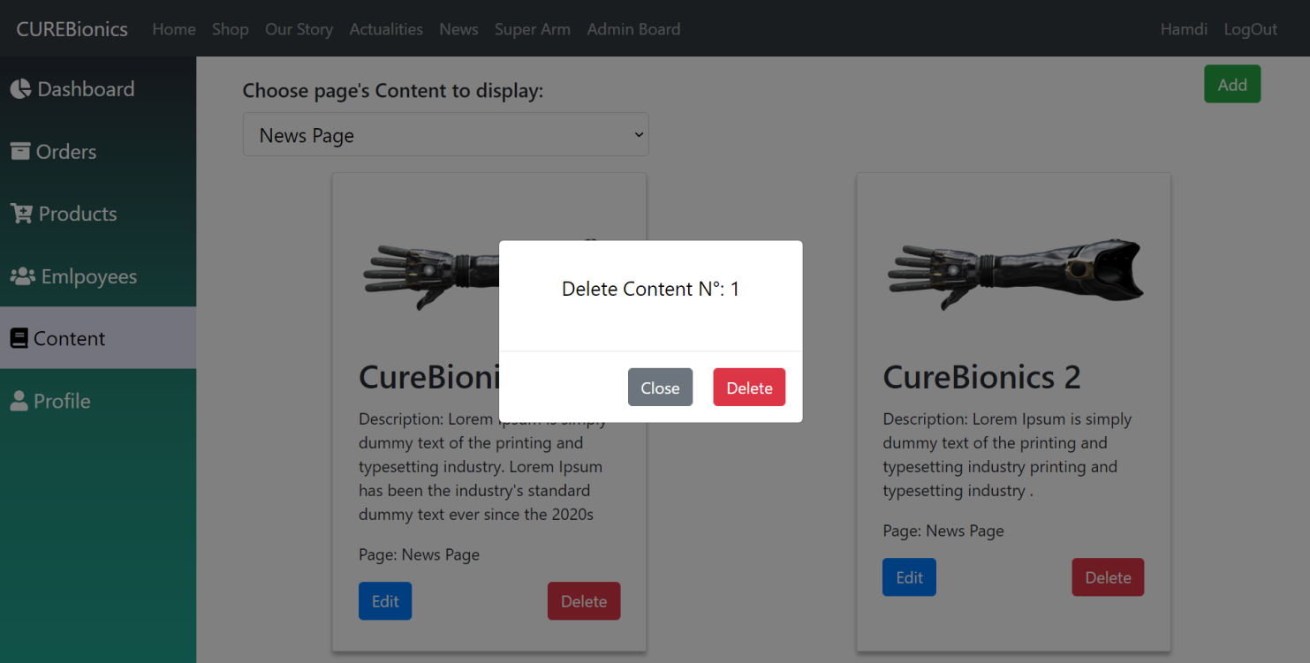

Figure ??: Delete Content Modal

## Tests

|  |  |  |  |  |
| --- | --- | --- | --- | --- |
| Use Case | Given | When | Then | Result |
|  |  |  | The system display add content component |  |
| Add new Content | The user is in contents manager component | The user clicks on add button ​ | The admin fills in content details | success |
|  |  |  | The admin click on save |  |
|  |  |  | The system saves new content in the database |  |
|  |  |  | The system display the existing products and an add product button |  |
|  |  |  | The user click on add product button |  |
|  |  |  | The system display add product component |  |
| Edit content | The user is in the content manager component | The user selects page to display its editable content and click edit | The system display edit content component | success |
|  |  |  | The user fills in new content details |  |
|  |  |  | The user click save |  |
|  |  |  | The system saves updates in database |  |
|  |  |  | System display delete content modal |  |
| Delete Content | The user is in the content manager component | The user selects page to display its editable content and click delete | User click on delete | success |
|  |  |  | System deletes content from database |  |

## Presentation of Sprint 2 monitoring tools

In this part, we will present the Scrum Board and the Burndown Chart of Sprint 2.

#### Sprint 3 Scrum Board

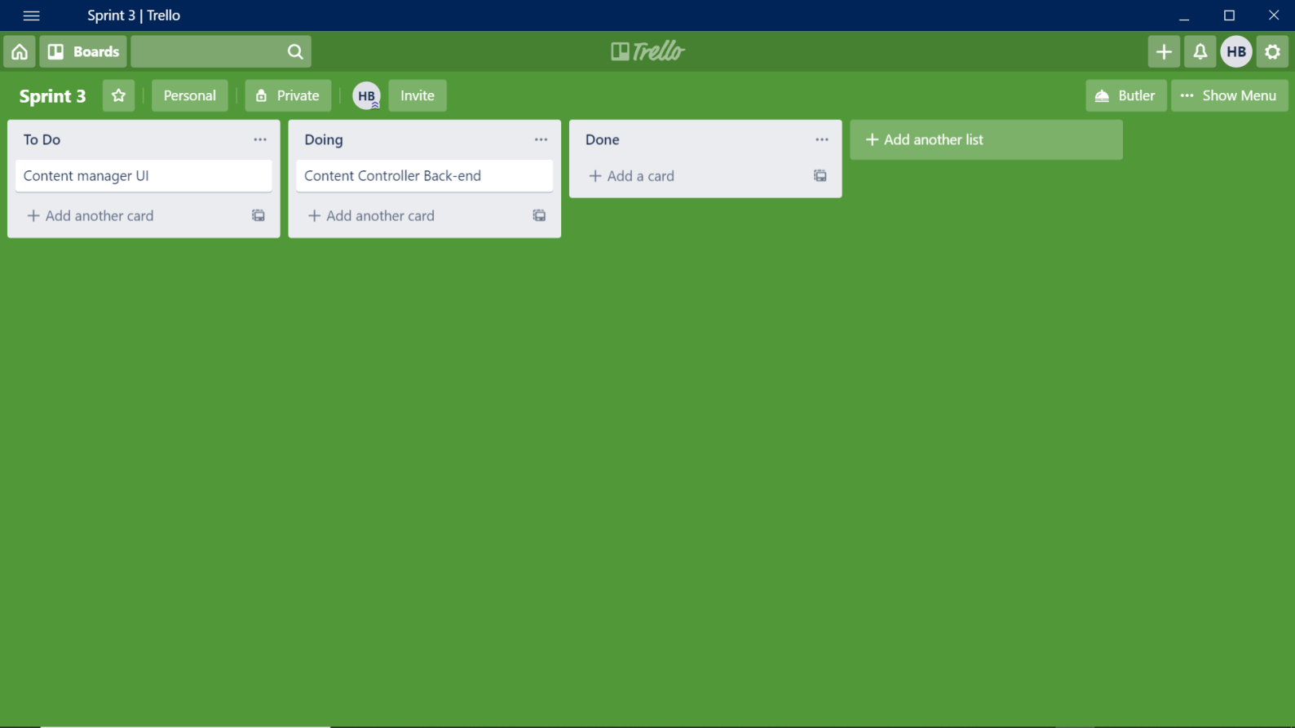 This is a board that allows you to follow the progress of the Sprint Backlog tasks in progress, It consists of three columns: To Do, Doing, and Done.

Figure ??: Sprint 3 Scrum Board

#### Sprint 3 Burndown Chart

Conclusion

In this last chapter, a presentation of the third sprint took place. And like every sprint, we went through 4 steps which are analysis, design, realization and test.

que faut-il ajouter dans ce chapitre?

# Chapter7: ???

**Plan :**

## Global Class Diagram

## Deployment Diagram

# Chapter 7: ????

Introduction

In this chapter we’ll present the global class diagram and describe some of the classes and the association between them then we’ll present the deployment diagram

## Global Class Diagram

## Deployment Diagram

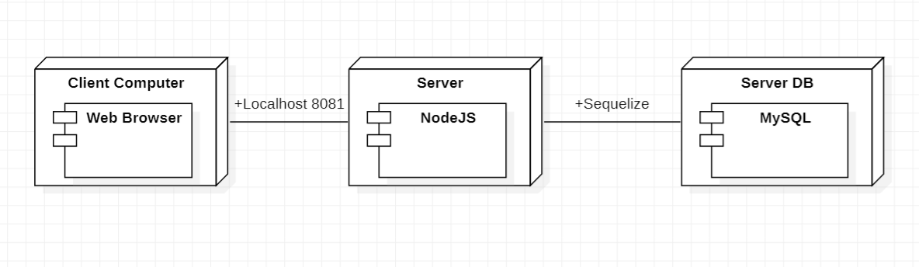 The use of the physical infrastructure by the system and the way in which the system components are distributed and the relationships between them are represented by the deployment diagram shown in the next figure

Figure 13: Global Deployment Diagram.

This system contains three nodes:

* **Client PC** with which users can access the system through a web browser.
* **The web server** that contains NodeJS.
* **The database server** that contains the MySQL database management system.

Conclusion

**General Conclusion and Outlook**

The objective of this end-of-study project is to realize a web application to help CURE BIONICS formulate its marketing strategy and develop an online store to overcome geographic restrictions and gain new customers with search engine visibility, also help international customers to explore CURE BIONICS and its products and order them online.

This report provides a detailed description of all the steps that had to be taken to arrive at the final result using the Scrum method which has been followed throughout the work to develop this application. To achieve the result we have followed a well-defined process. First of all, it was necessary to understand the general context of the requested work and to identify the different requirements of the application following meetings with the Product Owner and studies of similar applications. Then, the work schedule was prepared and cut out according to the different use cases of our application after a discussion between the development team and the Scrum Master. Then, we presented the working environment, tools and technologies used throughout our internship. Afterwards, for each sprint we exposed the functional specifications using a use case diagram followed by textual descriptions of some use cases before throwing light on a detailed design through the sequences diagrams and the class diagram. Finally, a description of the application was shown through screenshots and illustrations of some tests we did at the end of each sprint.

This internship was very interesting since it gave us an opportunity to deepen our knowledge in design, teamwork techniques and programming practice. In addition to that, it allowed us to learn new technologies and new languages that are currently in the spotlight.

In order to improve this project, it is proposed to enrich this application by focusing on some points. First of all, we propose to integrate an innovative mobile application to provide greater flexibility and allow CURE BIONICS to take limb’s measurements from pictures sent by the clients to avoid wasting time and to deliver products faster, second we proposed to put more work in design by a professional UI designer and provide high quality content (pictures, videos…) which will definitely help with creating a friendly environment for the visitors to grow CURE BIONICS revenues and help more people in the world with their high quality and low price products.

**Bibliography**

**Summary**

This project is developed within the context of the end-of-study project for the basic bachelor's degree in business informatics.

The objective of this project is to create an e-commerce web application for Upper Limb Prosthesis

In this internship report we presented the different stages of conception and realization of this application.

**Keywords:** React Js, Redux, BootStrap, MySql, Sequelize, SCRUM, Node Js and Express